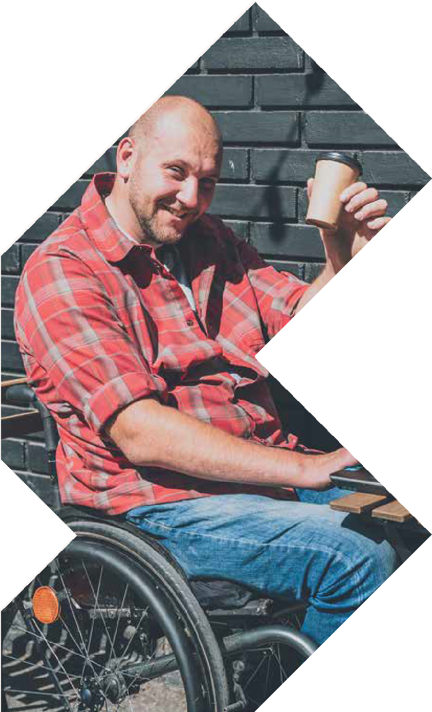
SYDNEY
22-23 MAY 2024
SYDNEY SHOWGROUND
Sydney Olympic Park, Halls 5 & 6

SEMINAR PROGRAM

EXPO OPENING HOURS
Wednesday 22 May 8:30am – 4:30pm
Thursday 23 May 8:30am – 3:00pm

events@atsa.org.au www.atsaindependentlivingexpo.com.au

Organised by Media Partners

SYDNEY 21 MAY 2024

Pre Expo Workshop

TUESDAY 21 MAY 2024
IAKS ANZ ATSA Seminar

AQUATIC ACCESS FOR ALL ABILITIES
$40 per person
9.00 am - 12.00pm Seminar Workshop 12.00pm – 12.40pm Lunch
12.40pm - 1.30pm Practical Session SOPAC

WORKSHOP PROGRAM

9.00-9.15 Welcome & Introduction
(15 minutes)

9.15 – 9.35 - Aquatic therapy (the Why)
(20 minutes)
- What is Aquatic Therapy
- Everyone should have the opportunity to experience Aquatic activities.
- Who benefits from Aquatic Therapy
  - Reduces weight bearing which reduces force of stress placed on the joints (especially useful for patients with arthritis, Exercise for people with hip or knee osteoarthritis, healing fractured bones, or who are overweight
  - Utilizes hydrostatic pressure to decrease swelling and improve joint position
  - Warmth of the water experience during aquatic therapy assists in relaxing muscles and vasodilates vessels, increasing blood flow to injured areas
  - General Health & Wellbeing

9.35 – 9.55 Pool Safety (the How)
(20 minutes)
- Pre-planning of Entry / Exit
- Safe Entry / Exit
- Safety during Aquatic activities

10.00 – 10.40 - Reducing Barriers
(20 minutes case studies & 20 minute panel)
- Commit to change and create the right environment
- Assessing the situation
- Consulting experts
- Create a culture for everyone, to add to safety
- Removing Physical, Policy, Social, Communication Barriers
10.40 – 11.00 - Where to go and what’s available (make it Happen)
(20 minutes)
- Pre planning phase
- Resources available
- Associations etc

11.00 – 11.20 - Building Clinicians Confidence (make it Happen) (20 minutes)
- Practical assessment
- Understanding the environment
- Gain confidence
- Continuing Professional Development (CPD Points)

WEDNESDAY 22 MAY 2024
8.00am 45 mins
ROOM 3

Wheelchair Scripting Mastery: A Skill-Building Process for Early Career Clinicians

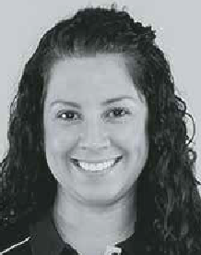
Bianca Brady - Clinical Education Co-Ordinator, APEX Mobility

Navigating the assessment and prescription of a manual wheelchair can pose
challenges for clinicians, particularly those engaging in this process for the first time. Factors like frame design, material
selection, component choices, and seating support require careful consideration with a collaborative and systematic approach.
This session is designed to empower clinicians, instilling confidence in their role in manual wheelchair prescriptions. It aims to equip them with the skills to identify key configurations that enhance user outcomes and navigate the scripting process with ease.
Gain CPD points

WEDNESDAY 22 MAY 2024
9.15am 45 mins
ROOM 1
ROOM 2

Creating Success: Navigating client expectations, environmental and functional demands. Considering Power Wheelchairs vs
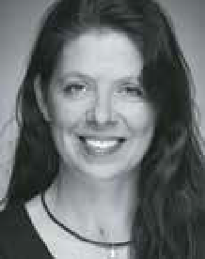
Power Add On Devices

Amy Bjornson - Clinical Director, Sunrise Medical

Powered mobility
technology has rapidly evolved in recent years. Now, we have a host of power wheelchairs and powered systems that can be added on to a manual wheelchair. Both are commonly considered as a solution when a manual wheelchair cannot provide the required functional outcomes. This workshop will focus on clinical implications and decision-making process. We’ll look the indications for these technologies
and use objective measures to qualify the technology for your client using case studies to foster learning.
Gain CPD points

NDIS Rules and Guidelines
- An OT’s Playbook to AT prescription

Sarah Collison - Director, Verve OT

Navigating and understanding the NDIS, it’s systems and processes can be
stressful, confusing and send many therapists into a tailspin on the best
of days! Understanding NDIS rules and how they apply to funded supports is essential to AT approval success in the NDIS. The NDIS rules set out the detailed operation of the scheme whilst the operational guidelines explain what the agency considers when making decisions based
on legislation. This session will provide a deep dive into the rules and guidelines most relevant to an OT’s scope of practice to increase knowledge and awareness when recommending AT funded supports.
Gain CPD points

WEDNESDAY 22 MAY 2024
9.15am 45 mins
ROOM 3
ROOM 4

Developing and Iterating the WeWALK Smart Cane

Joe Alfonso (Growth Manager) and Gökhan Meriçliler (CEO) - WeWALK

Through lived and professional experience of visual impairment, the WeWALK team has invented the WeWALK smart cane, a TIME Best Invention.
This session will explore WeWALK’s outputs and best-practice throughout its development, including R&D and commercialisation.

First time presenting at ATSA - International speakers

Start the Aquatic Access Conversation

Craig Slattery - Company Director, Aqua Access

Aquatic therapy is extremely advantageous as its beneficial in weight less motions, balance training, flexibility, and strengthening core muscles and improving mindset. This isn’t a
well-known area, and many miss out due misunderstanding or lack of confidence.
This session is designed to offer you some insights, life experiences, and to understand how this can be accomplished safety. We will touch on public aquatic facilities access and recommendations for improvements that will enable them to be more inclusive and the current state of the industry,
and we will be discussing residential opportunities.
Come and join our push to enable everyone the opportunity to experience the benefits of aquatics.

WEDNESDAY 22 MAY 2024
10.15am 30 mins
ROOM 1
ROOM 2

Bums, Bowels, and Bladder: Plane Travel and Things to Consider for Wheelchair Users

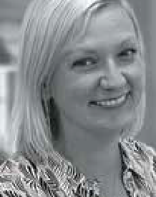
Tilly Brook - Clinical Education Specialist, Permobil Asia- Pacific

What main things do wheelchair users need to consider prior to plane
travel and what supports are out there to assist? How do we make sure pressure care needs are met on long- haul flights and how can wheelchair users safely complete their bladder and bowel care 30,000 feet high?
This presentation will review current EBP with reference to best practice guidelines for pressure care and bladder and bowel management and dive into practical solutions to ensure this can be completed on a plane.
Gain CDP points

Benefits of gel materials in seating

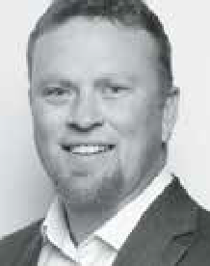
Chris Hawkins - VP of Sales, Blake Medical

Recent advances in dry polymer gel technology are creating new opportunities for skin integrity management in seating. Dry polymer gels behave more like a solid than a fluid. They do not
migrate, leak, or ooze out of shape, and can be engineered into sheets and columns of different shapes and sizes to offer immersive protection. They are naturally temperature regulating and vibration dampening – two properties considered important for seating surfaces.
This session will review various seating applications for dry polymer gels, including cushions and other seated support surfaces, bathtubs and bathing equipment, lift chairs, vehicles, and other surfaces.
First time presenting at ATSA - International speaker

WEDNESDAY 22 MAY 2024
10.15am 30 mins
ROOM 3
ROOM 4

Driving your wheelchair with your eyes

Loren Apokourastos - Assistive Technology Consultant,
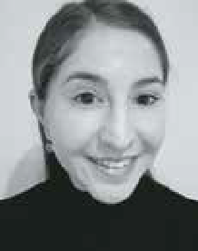
Link Assistive

This session will discuss how to control a wheelchair via eye-gaze. Recent technological developments have allowed for the integration of eye-gaze
technology and powered wheelchairs, for both driving and making chair adjustments. With access to an eye-gaze device, a powered wheelchair and a driving interface such as MyECC or Ability Drive, individuals can take control of their wheelchair.
We will discuss how the software and hardware works and demonstrate how to drive a wheelchair using eye control.

The importance of user feedback for inclusive assistive technology products and services

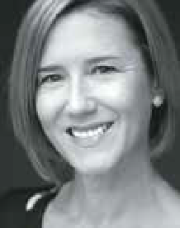
Liza MacLean - Head of Technology Implementation,
Remarkable/Cerebral Palsy Alliance
Despite advances in assistive technology
(AT) for people with disabilities, many new technologies are designed without understanding the diversity of user needs, resulting in products and services that are less than optimal for intended users.
Inclusive design aims to make solutions that are accessible and usable by the greatest number of people possible. It is a continuous practice that requires technology developers to have inclusive mindset and seek ongoing feedback to
learn from the diversity of disabled lived experience.
This session will outline inclusive design principles and how users can get involved and contribute feedback to directly influence startups developing emerging AT.

WEDNESDAY 22 MAY 2024
11.15am 45 mins

ROOM 1
ROOM 2

Matching the Levels of Mobility Impairment to AT Solutions: Establishing Positive Client Outcomes
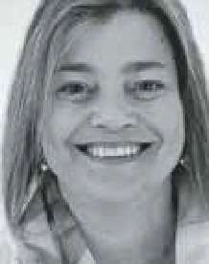
Lois Brown -National Clinical Education Manager, ILS and Prithy Sivaraman
- Physiotherapist, Sunrise Medical

Paediatric Panel -
come prepared with your questions to ask the Panel

MODERATOR: Robert Norman – National Educator, RTD
This fully interactive session answering your questions and challenges in a big world of Paediatrics.

We all have referrals for clients with varying degrees of physical mobility impairment and hidden disabilities which limits their activities
and participation in their daily lives. The assessment process and
equipment prescription is about matching those needs to the body structure and function (postural seating needs) while taking into consideration environment of use. A mobility algorithm can guide us in the prescriptive process, ensure a positive person-centered outcome and help in our funding applications.
There are a lot of factors to consider in determining the need in moving from one category of mobility aid to another, and this session will help you do just that.
Gain CPD points

PANELISTS:
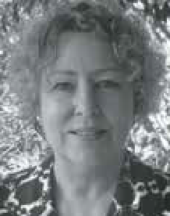

Susan Terds – CEO, Kidsafe Queensland

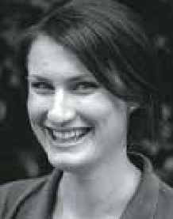
Prue Nix - Clinical Director (OT), Child First Therapy

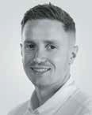
Jamie Cockle – Medifab Clinical Educator
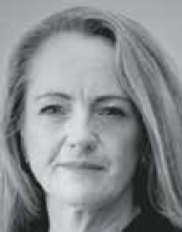
Melinda Fitzgerald
- Clinical Educator (PT), Apex Mobility

WEDNESDAY 22 MAY 2024
11.15am 45 mins
ROOM 3
ROOM 4

How Do People Actually Use Their Manual Wheelchairs, and What Really Matters?

David Fagan - Managing Director, Paragon Mobility

Selecting wheelchair frames, components, dimensions, and setup requires knowledge of factors including the physics of propulsion, and how materials
and design characteristics influence performance. This presentation examines the combined effects of wheelchair materials, design, component selection, dimensions, and setup. It covers general physics principles along with positioning needs, environmental use, activity performance, and capacity for modification.
The presentation addresses questions including: Why choose monotube versus dualtube frame designs? Does frame weight matter? Which materials are better at damping vibration? How can we effectively reduce rolling resistance? Aside from horizontal axle placement, what needs consideration when changing the centre of mass/gravity?

Caroma Age Lab Workshop
Dr Adeline Chua - Head of Customer Insights & Programs and
Dr. Peter Sweatman - Senior Manager Product Visualisation,
Caroma Industries
Delivering to a universal mindset in design, starts with having true empathy as to how any designed products will
need to be used. Building empathy therefore becomes a powerful method for incorporating inclusivity into the design thinking process, ensuring delivery of products and services that respect different life experiences to your own.
With an increasingly ageing population and with so many older people choosing to age independently in their own homes appropriate, usable, and appealing design has never been more important. The GWA Age Lab Workshop has been established to enable participants to feel some of
the effects of the ageing process as they perform typical daily tasks. The experiential portion of the 90-min workshop introduces attendees to the AGE SUIT system, which comprises wearable components that simulate a range of age-related impairments such as reduced mobility, back pain, visual impairments, and Parkinson’s-like tremor.
This process helps highlight the benefits of universal design features and environments as well as prompting insights into how better designed outcomes can be achieved.

WEDNESDAY 22 MAY 2024
12.00pm 30 mins
ROOM 3

Adaptive Cycling as an Effective Intervention

Lori Potts, Rifton

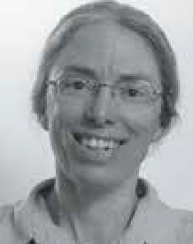
Adaptive cycling offers a solution to promote health as described
by the International Classification of Functioning, Disability and Health.
This session incorporates
an overview of the specific benefits of cycling as evidenced in research with children with cerebral palsy and autism and discusses the use of adaptive cycling as
a successful strategy for physical activity promotion.
Case examples will illustrate benefits of cycling within the comprehensive basis of the ICF F-Words model for childhood disability.

WEDNESDAY 22 MAY 2024
1.00pm 45 mins
ROOM 1
ROOM 2

NDIS
Dr Lloyd Walker

Occupational Therapy Australia panel session – Beyond equipment: The occupational therapy role in assistive technology provision
Occupational therapists play a pivotal role in the assessment, prescription, training, and purposeful integration of assistive technology into individual’s lives.
Core to the AT occupational therapy process is a person-centred focus aimed at enabling optimal participation in meaningful activities and life situations. Choosing the right assistive technology and overcoming any barriers is a team effort between client/ participant, carers/families, AT supplier and the occupational therapist.
Join us for an engaging panel discussion featuring occupational therapy experts including Assoc Prof Libby Callaway, Sarah Collison and Justin Boulos, as we delve into the unique approach that occupational
therapists bring to the provision of assistive technology in Australia.
Don’t miss this opportunity to gain valuable insights and strategies from leading professionals in the field. This session is relevant for all allied health professionals, AT suppliers, students, support professionals and consumers.

WEDNESDAY 22 MAY 2024
1.00pm 45 mins
ROOM 3
ROOM 4

Why ‘nearables’ will soon overtake ‘wearables’ in the smart bedroom!

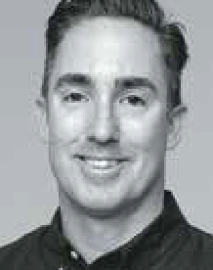
Cameron van den Dungen - Founder & CEO -
Sleeptite

For over 15yrs, Cameron van den Dungen has travelled the world searching for innovation and technology in sleep
science and research focused on ‘what is next’ for the sleep industry, and how the bedroom can evolve as part of the smart home, hospital, barracks, or boarding school. Cameron uncovered gaps in the quality of the data collected by existing sensors as well as limitations in the application of existing technologies. In this session, Cameron will discuss why ‘nearable’ technology promises to deliver far better outcomes for the individual and their support networks in assisted living settings.

First time presenting at ATSA

On the Road Again: Transport Considerations Across the Lifespan

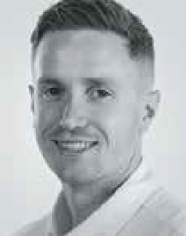
Jamie Cockle - Clinical Educator, Medifab and Omid
Akbarian - Solutions Specialist, Mobility Engineering
Discover the importance of personalised transport solutions
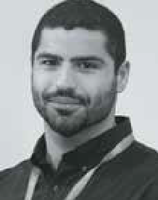
for individuals with medical conditions and disabilities, addressing safety, well-being, and comfort concerns. In this informative session, we delve into the inadequacies of off-the- shelf products designed
for ‘typically developing’ children through to adults and emphasise the need for specialised options that cater to the unique requirements of individuals throughout their lifespan.
Our journey spans from infancy to adulthood, highlighting specific focus areas for each age group. Once armed with an understanding of transport plans, we shift our focus to practical solutions within the realms of Car Seats, Vehicle Seat Positioning, Transfers, and Wheelchair Access.
This session will explore how personalised transport solutions can promote a lifetime of safety, comfort, and well-being for individuals with disabilities, transforming travel experiences at every stage of life.
Gain CPD points

WEDNESDAY 22 MAY 2024
2.15pm 30 mins
ROOM 1
ROOM 2

How accessibility accommodations and inclusion enabled a career in Antarctic science –
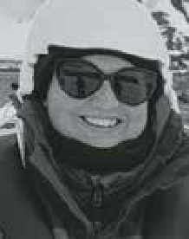
and the trip of a lifetime!

Diana King - Deputy Program Manager, Securing Antarctica’s Environmental Future (SAEF),
University of Wollongong

As a disabled person, empowerment to be independent and autonomous is so important. When you aren’t able to do
things and make choices that everyone else takes for granted, it is really disabling.
As an Antarctic scientist, Diana faced many barriers to achieving her goals, including completing a whole PhD without ever having a clear idea of exactly what her study sites actually looked like.
But in 2023, with plenty of self-advocacy and accessibility accommodations, Diana was finally able to fulfil a dream that she never imagined would become reality – participating in a voyage to Antarctica!
First time presenter at ATSA

Assistive Technology (AT) in Australia: Current opportunities and
challenges for the AT sector

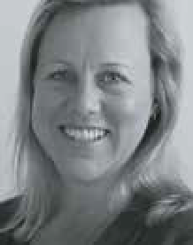
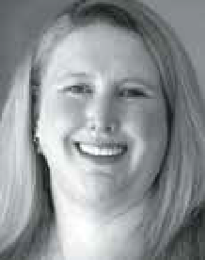
A/Prof Libby Callaway - 2024 Strategic Executive Advisor and Dr Melanie Hoyle - 2024 President, Australian Rehabilitation and Assistive Technology Association (ARATA)
Australia continues to undergo major reforms across health, ageing and disability. These reforms are significant for both people who
use Assistive Technology (AT), as well as those who advise on, develop or supply AT. This presentation by the Australian Rehabilitation and Assistive Technology Association (ARATA) – a national peak body for AT stakeholders – will outline current opportunities and challenges in the Australian AT sector, and link these to both national and international AT policy.
Information resources and strategies to inform both consumer and service provider experiences of AT products, provision, personnel and policy will be detailed.
Recommendations for further action in the AT sector will be discussed.

WEDNESDAY 22 MAY 2024
2.15pm 30 mins
ROOM 3
ROOM 4

Suspension and Motors – Hidden, but not Forgotten

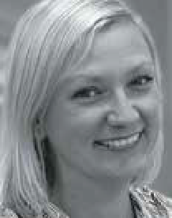
Tilly Brook - Clinical Education Specialist - Permobil Asia-Pacific

Suspension and motors are hidden under the shroud of a Power Wheelchair (PWC),
but out of sight should not mean out of mind. In fact, the motor and suspension of a PWC
have significant implications on function – where a person can go and how they feel when they get there. After this session, you will feel more confident when considering the elements under the shroud of a PWC: how they can differ between chairs and what questions to ask to match it to your client’s needs and goals. What is under the shroud should never be an afterthought!

Gain CPD points

Solving mental and physical health challenges through adaptive fashion!

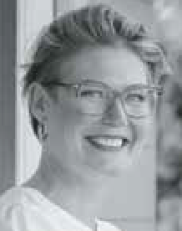
Jessie Sadler - CEO & Founder, Christina Stephens

Adaptive clothing is estimated to be worth over $400 billion globally in 2023. In Australia adaptive clothing is fully
NDIS and HCP fundable and is considered an assistive technology.
The mental health benefits of inclusive fashion cannot be underestimated. Being ‘seen’ and ‘heard’ and able to express your individual self is paramount to positive mental health outcomes.
Through lived experience we understand the physical risks that disabilities may present, such as temperature regulation, sensory challenges and deadly pressure sores. Approximately $9 billion is spent in Australia annually on pressure sores, of which $3.5 billion goes directly into treatment.
The vast mismatch between prevention and treatment has been a healthcare blind spot, a gap that we are helping to bridge through our innovative adaptive clothing designs.
First time presenters at ATSA

WEDNESDAY 22 MAY 2024
3.15pm 45 mins
ROOM 1
ROOM 2

The future of prescription – what role will AI play

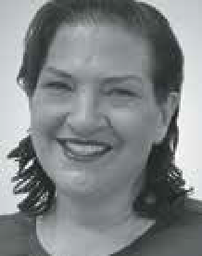
Tracee-lee Maginity - Clinical Services Specialist - Permobil APAC

One of the biggest technological advancements currently facing industries globally is the implementation
of Artificial Intelligence (AI) What can AI offer in the area of prescribing
AT. Is it a tool that can assist in the ever- increasing amounts of report writing associated with the justification processes of prescribing Assistive Technology? Can it assist us manage the paperwork demands. What are some of the advantages and disadvantages of using these technologies to complete funding justifications?
This session will provide a historical understanding of the development of AI and consider the ways in which it may be applicable to current practice. Discussion on the foundations of clinical reasoning will guide the group in considering the role AI may play in future prescription processes. This session will be interactive, and every attendee will have an opportunity to contribute to the discussion through use of a real live online tool.
Gain CPD points

Big and Brilliant: Accommodating the range of Bariatric shapes for patient handling and positioning

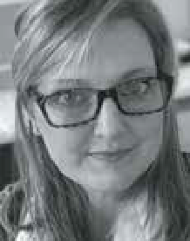
Elissa Coates - National Clinical Education Manager, Novis Healthcare

Each human body is unique in size,
dimensions and weight.
This is no different for clients who are assessed with obesity.
Implementing a one size fits all approach to bariatric assistive technology will fail to
achieve outcomes such as comfort, reduced risk of adverse events, and encourage maximisation of independence.
In this session we will look at:
- Main somatotypes of the bariatric client body
- Individual movement and positioning needs of each body type
- Shape associated seating requirements
- Implications for provision of assistive technology
By the end of the seminar you will have a more holistic view of the bariatric client to enable you to make informed decisions leading to successful outcomes for
improved quality of life and quality of care.
Gain CPD points

WEDNESDAY 22 MAY 2024
3.15pm 45 mins
ROOM 3
ROOM 4

Expanding the circle

Edward Levy and Mike O’Brien - Business development Manager, NeuroMobility, Ottobock

For those people who have neurological compromise of either one or both of the lower limbs, the confidence
to stand and mobilise safely is lost and an easy solution is wheelchair scripting. However,
not only has orthotic knee joint technology improved, but also the way clinicians are assessing clients is
allowing more people to have a better chance at standing again.
Let’s have a look at how some clinicians are thinking differently about our assessment techniques and how this enables widening the client selection for KAFO management.

Staging Pressure Injuries- Getting it Right

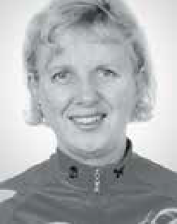
Tracy Nowicki, Clinical Nurse Consultant

Pressure injuries are localised, avoidable, and mostly preventable. They are painful, incur significant costs, and are considered a form of neglect. Accurate staging of pressure
injuries is crucial for proper reporting and, more importantly, for achieving optimal patient outcomes. By accurately assessing and documenting the pressure injury stage, healthcare professionals can provide appropriate treatment and implement preventive measures to promote healing and prevent further complications.
This session will explore the following.
- What are the causes of Pressure Injuries?
- Updated Pressure Injury Categories, 4 Stages + 2 Temporary Categories + Mucosal Category
- What makes Pressure Injury Stages/ Categories different?
- Why does the mucosal Pressure Injury sit on its own?
- Can you backstage Pressure Injuries?
- What does skin colour have to do with Pressure Injury staging?
Gain CPD Points International speaker

THURSDAY 23 MAY 2024
8.00am 45 mins
ROOM 3

Know your way around standing frames. A practical session measuring for both fitting and growth
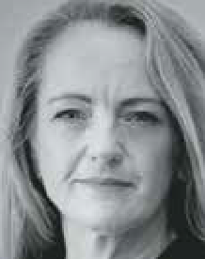
Mellinda Fitzgerald
- Clinical Educator - APEX Mobility and Robert Norman, National Educator, RTD

THURSDAY 23 MAY 2024
9.15am 45 mins
ROOM 1
ROOM 2

All about Power Assist Devices (PAD)

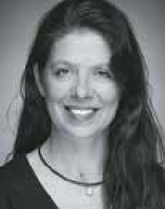
Amy Bjornson, Clinical Director - Sunrise Medical

Power Assist Devices have rapidly evolved in recent years. They are commonly considered as an alternative to a power wheelchair or as a method of making a manual wheelchair a
more functional option.
This workshop will focus on clinical implications and decision process for each category. We’ll look the indications for these technologies and objective measures useful to qualify the technology for your client. We’ll also discuss education and training strategies to maximise functional gains.
Gain CPD points

Are We Satisfied With Current Seating Technology Outcomes Or Should We Strive To Achieve More?

Filipe Correia - Latin America and Europe, Business Development Manager, Stealth Products, LLC
Seating systems providing
wheelchair users with PSIS, and lumbar support and back support reclining systems are common practice when dealing with seating challenges such as postural fatigue, user discomfort and passive seating and sliding. While PSIS, lumbar support and back support recline systems can provide many benefits to wheelchair users, there are limitations to consider.
This presentation will provide an in-depth biomechanical analysis of the outcomes of PSIS, lumbar support and back support recline interventions and will illustrate
the limitation of such interventions using case studies. In addition, the benefits of an alternative seating approach whereas independent and dependent adjustments for postural changes for function, absorption of repetitive loading and for low shear seating interventions will be discussed.
First time presenting at ATSA – International speaker

THURSDAY 23 MAY 2024
9.15am 45 mins
ROOM 3
ROOM 4

Supported lying – implementing successful night time postural care

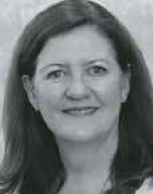
Jacinta Maurin - Postural Care and Paediatric Unit Manager, Sunrise Medical
This is a basic to intermediate course considering the postural
needs of the Paediatric population with a focus on night time positioning. We will consider tone, growth and abnormal postures and how night time or lying
positioning systems can assist to meet both clinical and functional goals.
Clinical objectives include:
- The power of 24-hour posture support
- Night time supported lying of paediatric clients while considering growth and ease of use
- The maximization of health, posture and function for paediatric clients
Gain CPD points

Overcoming Pain Barriers: Maximising Participation and Achieving Lifestyle Goals for Wheelchair Users

Kate Pain - Consultant, Clinical Educator and Romi Russek - Consultant, GTK
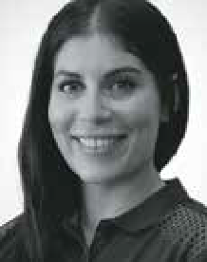
What is pain and why do we experience it? How does pain limit the ability of people using wheelchairs to achieve their goals and live the life they want to live? Chronic pain is a common experience for individuals living
with mobility challenges and can often be overlooked when prescribing and assessing assistive technology needs. Understanding our client’s experience is important when supporting them to achieve their functional and participation goals.
This presentation will explore pain as a barrier to participation, focusing on the unique challenges faced by wheelchair users. We will discuss common causes of pain and how they relate to aspects of the seated position in a mobility device to either enhance or reduce function.
We will also advocate for pain to be included as a domain in assessment for assistive technology, and for specific goals to be set to maximise participation, while considering pain as an inhibiting factor.
Gain CPD points

THURSDAY 23 MAY 2024
10.15am 30 mins 10.15am 30 mins
ROOM 1
ROOM 2

Myth Busting Palliative Care

Kirsty Blades - CEO, Palliative Care NSW

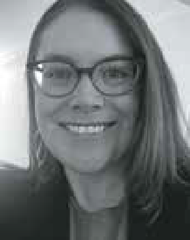
Curious about what palliative care is? Have heard the words but aren’t really sure who can access palliative care, how and when it can be accessed and what it means? The Sydney ATSA Independent Living Expo coincides with
National Palliative Care Week and is a great opportunity to learn the answers to these questions and what palliative care can mean for you as an individual, for families and carers, and/or for your clients. There are a lot of myths about palliative care and we want to take this opportunity to bust them for you! Myths like palliative care is only for people with cancer, palliative care means I have given up hope or palliative care means losing my independence.
Palliative Care NSW supports access to, and equity of, quality palliative care for everyone. Come along and then share your new knowledge with peers and colleagues.
Everyone who attends the session will receive a printed copy of our Palliative Caring booklet and our National Palliative Care Week heart pin that symbolises care and support and living your life as well as you can to the
very end. Dr Peta McVey, our Palliative Care Guidance Manager will also be on hand to answer questions. Peta is a registered nurse with extensive palliative care expertise having worked as a senior clinician in specialist palliative care services for 18 years.
First time presenting at ATSA

Prescriber Confidence in Complex Wheelchair Seating: platform to support clinicians

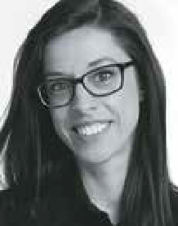
Joana Santiago - Head of Clinical Education and R&D
Clinical Lead, Medifab
Wheelchair seating provision can be a complex process, requiring detailed assessment and consideration of numerous variables. Analysis of
recent education feedback indicates that therapists often cite a “lack of confidence” when assessing their clients’ mobility and seating needs, and struggle to translate their assessment findings into product requirements and features.
With that in mind, this new digital platform has been designed to equip therapists, rehab engineers and seating product specialists with a tool to support the step-by-step physical examination process. Users can store individual client data securely, providing a log for assessment findings over time in
a password protected environment. Body measurements and postural support needs can be inputted and then transferred into a 3D model, providing visualisation of client presentations that can be shared among stakeholders involved in the prescription process. With clearer understanding of client presentation alongside digital representation of assessment findings, product selection and configuration can ultimately be improved.
This presentation will provide live access to all attendees and will demonstrate features and opportunities for therapists to be thorough, increase their confidence and support their clinical reasoning process to achieve successful clinical outcomes.
Gain CPD points

THURSDAY 23 MAY 2024
10.15am 30 mins
ROOM 3
ROOM 4

Options for safely transporting adults and children with disabilities and medical conditions

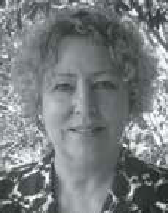
Susan Teerds – CEO, Kidsafe Qld and Disability Safe Seating Solutions

What are my choices for safely transporting adults and children with
disabilities and medical conditions in motor vehicles, motor homes, buses and planes.
This presentation will explore the Road Rules, Australian Standards, the use of specialty harness and modified child car restraints. Off-the-shelf car seats can provide great support for low-tone medical needs and also behavioural issues. Do you need a qualification to modify seats? How do you choose between a harness, a car seat or a wheelchair in a vehicle? What is safer? Who can you ask?”
Gain CPD points

Paediatric seating and the benefits of 24-hour postural support

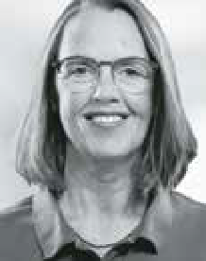
Andrea Espei - Head of training, Schuchmann Reha

Many children with motor impairment spend prolonged hours in
their carefully designed seating devices, in which they are also carefully positioned. Modular
or adaptable seating systems offer good trunk stability, pelvis and foot positioning options and head control. The goal of these seating systems is to compensate for a lack of certain body functions and to support and guide the physiological development of body structures.
This talk explains how to use evidence to evaluate the results of postural
management. Specifically, we will look at:
- how to choose the right type of support
- how to determine the right support in the right place (e.g. the height of the back support)
- how to design variable and task- orientated seating positions
- how to set up a high-quality postural management program that includes variable seating.
International speaker

THURSDAY 23 MAY 2024
11.00am 45 mins
ROOM 1
ROOM 2

The Impact of Lying, Sitting and Positioning on Respiratory System Function

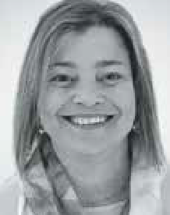
Lois Brown - National Clinical Education Manager,
ILS and Sarah Uncle - Clinical Educator,
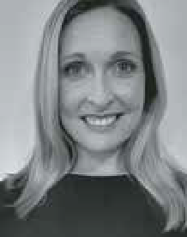
This session will help you keep respiratory function in the forefront of your mind when
you are assessing and applying equipment solutions in lying
and sitting. Knowing the biomechanics of breathing and how that is affected by a client’s position is critical
for all clients.
We might see ‘optimal posture’, but a respiratory therapist may see an overly restricted abdomen and chest wall. It is imperative we have enough general
knowledge and awareness of respiratory function to ensure our efforts do not compromise our patients breathing.
Gain CPD points

Finding Balance: Creating functional stability for wheelchair users

Jacelyn Goh - Occupational Therapist | Clinical Educator | Product Specialist, Linds Rehabilitation
Take it from an experienced wheelchair seating clinician, the
hardest wheelchair users to provide postural supports for are the ones who move!
Any therapist prescribing wheelchairs will confidently tell you that we must start at the pelvis! But do we truly understand what it means to create a stable base support?
What happens to the base of support when the wheelchair user moves in and out of positions to function? What components
on the wheelchair frame and seating system can we use to enhance participation for
the individual?
This session will take you on a journey through the assessment process to make our client centered outcomes match the features we prescribe in available product.

THURSDAY 23 MAY 2024
11.00am 45 mins
ROOM 3
ROOM 4

Exploring the Potential: Maximising Independence Through Electronics in Complex Power Wheelchairs

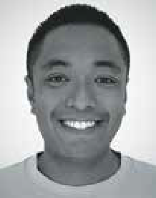
Andrew Lopez - Product Specialist & Clinical Educator, Quantum Rehab

Complex power rehab wheelchairs have some of the most advanced
electronics in the complex rehab industry. Maximising a user’s independence should always be the goal of the team providing the wheelchair to the individual.
Despite being a valuable tool, Bluetooth is a vastly underutilized technology that most manufacturers have built into the expandable electronics. This seminar will
focus on the power of Bluetooth technology and how we can combine this with smart technology that is readily available on the market to maximise independence within an individual’s environment.

Addressing Paediatric Hip Health: Practical Approaches for Positive Outcomes

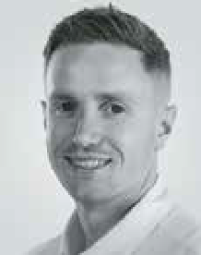
Jamie Cockle - Clinical Educator, Medifab

Navigating the complexities of paediatric hip health is essential when working with children with
neurological impairments and disabilities. This session delves into the prevalent challenges associated with hip joint issues and their secondary complications in this population. We explore the significance of consistent postural support throughout the day and night, coupled with opportunities for weight-bearing and active movement in promoting optimal hip health.
Join us to unravel the intricacies of hip development and health within the neurodisability population. The focus extends beyond theory to practical considerations, highlighting the essential balance between 24-hour movement and 24-hour postural care. Gain insights and actionable strategies to make a positive impact, paving the way for a healthier future.

THURSDAY 23 MAY 2024
12.00pm 45 mins 12.15pm 30 mins
ROOM 1
ROOM 4

Pressure and Posture in Lying: A Vital Duo Often Overlooked

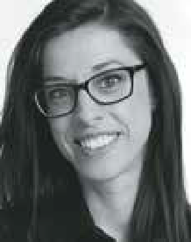
Joana Santiago - Head of Clinical Education, MediFab and Sarah Uncle - Clinical Educator, ILS Hospital and Pressure Care Team
Clients with complex and continuing healthcare needs face a silent, ongoing battle—unseen changes in body shape and increased risks of pressure injuries when lying. This can happen slowly over a long period
of time and may affect a person who has difficulty moving efficiently, irrespective of diagnosis or age.
This session provides you with strategies to protect clients from the risks of static, destructive postures while protecting their skin. Pressure care principles, support surface selection and therapeutic positioning systems will be discussed.
Grounded in the latest clinical evidence and international guidelines, this session prompts a re-evaluation of current practices.

Pressure Mapping Technology

Nabil Kodsi - Clinical Education/ Product Specialist, Specialised Wheelchair Company

Pressure mapping technology has emerged as a vital tool in the
field of wheelchair seating assessment and optimization. There should be a balance between
client’s goals and aspirations and Occupational therapist’s recommendations. Critical thinking constitutes a fundamental aspect of our ability to access quality information and knowledge to form a well-founded opinion or to make informed decision.
By accurately measuring pressure distribution between the body and the wheelchair surface, XSensor Foresite SS enables healthcare professionals to identify and mitigate potential pressure ulcers,
a common concern among wheelchair users. Additionally, it aids in optimizing seating posture, reducing discomfort, and preventing musculoskeletal issues associated with prolonged sitting. Through real-time feedback and data-driven adjustments, pressure mapping technology empowers individuals with tailored seating solutions, promoting greater independence, mobility, and overall quality of life for wheelchair users.
This session will explore the application of pressure mapping systems, enhancing the well-being and comfort of individuals using wheelchairs in combination with OT reflexions regarding what we observe, assess, and understand.

THURSDAY 23 MAY 2024
1.00pm 30 mins
ROOM 1
ROOM 2

Adaptive Clothing Fashion Show
Applying evidence-based practice when assessing
and prescribing for children’s car seating needs

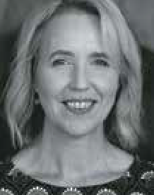
Helen Lindner – Chief Executive, MACA

MACA is leading an unprecedented research and work program which is building a new
evidence base for allied health professionals supporting the motor vehicle transport
of children with disabilities and medical conditions.
This includes work conducted by MACA’s Australian Safety Assessment Program; a large-scale research project investigating specialty harnesses/vests; the development of specialist training courses; and research led by Neuroscience Research Australia investigating child restraint modifications. There are also some new developments in key standards and regulations relating to transporting children with disabilities and medical conditions.
MACA Chief Executive Helen Lindner will share some of these exciting new findings and developments. Discover how you
can apply evidence-based practice in this rapidly evolving research, standards, and legislative environment.

THURSDAY 23 MAY 2024
1.00pm 30 mins
ROOM 3
ROOM 4

Wheelchair secondary supports – clinical reasoning & selection process:

Edward Milner, Medifab

Wheelchair seating and postural positioning play a pivotal
role in optimizing the physiological
function, occupational performance and body structure of individuals
with mobility challenges. Therapists employ primary supports, such as back supports and cushions, in conjunction with wheelchair bases, to improve postural alignment, pressure care, and overall comfort. Often, the judicious use of secondary supports, like anterior pelvic or trunk supports, is crucial to achieving desired physiological and functional outcomes for the wheelchair user.
However, there has been cases of misuse of secondary supports leading to alarming events, including injuries and fatalities.
This has prompted regulatory bodies such as the NDIS Quality and Safeguards
Commission and the Aged Care equivalent to scrutinize and develop guidelines to minimize or eliminate the use of regulated restricted practices.
By elucidating the purpose of secondary supports and emphasizing evidence- based practices, this seminar endeavors to empower therapists with the knowledge necessary to navigate this critical aspect of wheelchair seating, ensuring the safety and well-being of wheelchair users.

Pelvic Belts – more than just an afterthought, and definitively not a seatbelt!

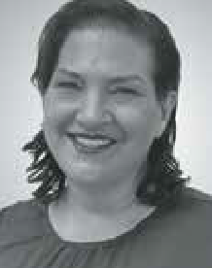
Tracee-lee Maginnity - Clinical Services Specialist,
Permobil APAC

We often spend considerable time assessing and looking at back supports and cushion solutions to
meet someone’s seating needs.
The final point of control or postural support is often an anterior postural support accessory such as a pelvic positioning belt or harness. How this is positioned is essential to the postural outcome, and if incorrectly mounted can undo all the positioning of the cushion and backrest.
This session will investigate where pelvic belts are fitted and the impact correct (and incorrect) mounting and positioning has on postural and functional control.
Gain CPD points

THURSDAY 23 MAY 2024
2.00pm 45 mins
ROOM 1
ROOM 2

The 6 P’s For Success Supporting Fixed Postures – A Case Study

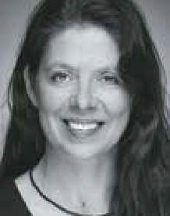
Amy Bjornson, Clinical Director - Sunrise Medical

This session walks through the steps of consideration and compromise when translating postural assessment findings into a functional seating and
mobility prescription for our more complex clients. We’ll provide practical tips and ideas during the decision-making process: how to simulate postural supports, how to ready yourself for a successful equipment trial with the supplier and the client.
Gain CPD points

Saying Assisted - The Challenge of AT Compliance

Elissa Coates - National Clinical Education Manager,
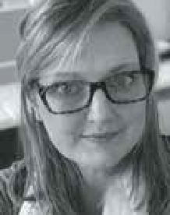
Novis Healthcare

With over 35% of Users abandoning AT within the first year, understanding the causation and appropriate preparatory actions is essential to Therapists. Each party
involved has a responsibility to positively impact the AT experience including caregivers, families, therapists, AT suppliers and AT designers. Understanding the evidence-based impact each can have assists in Therapists overseeing implementation as successfully as possible.
In this session we will:
- Understand the complex nature of abandonment
- Analyse evidence-based factors improving compliance
- Determine the factors that design and supply of AT has on the outcomes
- Interventions from Therapists for positive effects
- Review AT that is in line with current evidence
By the end of the session Therapists will have clear understanding of the factors contributing to positive compliance with AT recommendations.
Gain CPD points

THURSDAY 23 MAY 2024
2.00pm 45 mins
ROOM 3
ROOM 4

Reaching New Heights: How Power Seat Elevation can Maximise Participation and Independence

Kate Pain - Consultant, Clinical Educator and Romi Russek - Consultant, GTK
Have you had a recent rejection from the NDIS of power seat elevation
(vertical lift) on the grounds that it doesn’t meet the ‘reasonable and necessary’ criteria? We hear you! This presentation will focus
on the essential role that power seat elevation (vertical lift) plays in maximising participation for
power wheelchair users and people supporting them. We will unpack why this function should be considered as reasonable and necessary for power wheelchair users.
There is strong momentum for seat elevation to be funded under insurance schemes globally, with funding bodies identifying seat elevation as an essential feature. We will present the evidence from the literature that has led to the funding body decisions and share case studies that demonstrate how power seat elevation enables clients to achieve their goals as a stand-alone feature, or in combination with other power seat functions. We also will highlight the importance of considering an individual’s physical and functional abilities, as well as their environmental and lifestyle factors when determining which power seat functions are best suited for them.
Gain CPD points

Mobile Shower Commode Chairs for people with larger bodies

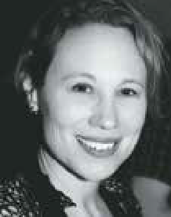
Emma Friesen - Product Portfolio Manager, Paragon Mobility

People with larger bodies may experience challenges in undertaking activities
such as toileting, intimate hygiene, and bathing. They may need AT – specifically mobile shower commode chairs (MSCCs) - with higher weight capacities and size, and that require greater circulation spaces in the physical environment.
This workshop will focus on assessment, selection, specification, and set up of these MSCCs. The workshop will include an overview of Dionne’s five bariatric body types, tips for optimizing seating and postural support, and discuss clinical justification for various options and accessories.
Gain CPD points

