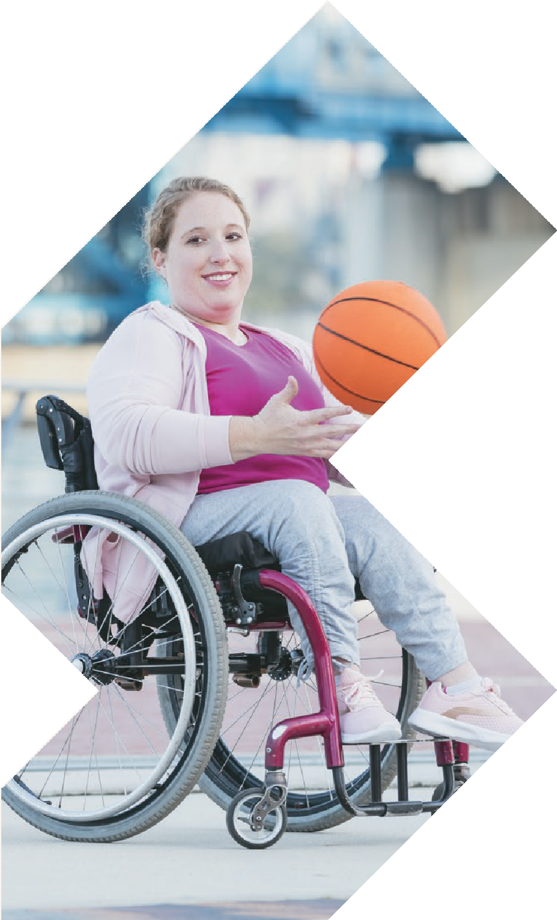
BRISBANE
29-30 MAY 2024
BRISBANE CONVENTION & EXHIBITION CENTRE
Cnr Merivale & Glenelg Streets, South Bank, Brisbane

SEMINAR PROGRAM

OPENING HOURS
Wednesday 29 May 8:30am – 4:30pm
Thursday 30 May 8:30am – 3:00pm

events@atsa.org.au www.atsaindependentlivingexpo.com.au

Organised by Media Partners

WEDNESDAY 29 MAY 2024
8.00am 45 mins
ROOM 1

Wheelchair Scripting Mastery: A Skill-Building Process for Early Career Clinicians

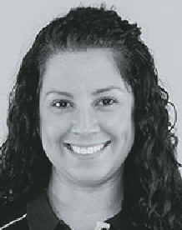
Bianca Brady – Clinical Education Co-Ordinator, APEX Mobility

Navigating the assessment and prescription of a manual wheelchair can pose
challenges for clinicians, particularly those engaging in this process for the first time. Factors like frame design, material
selection, component choices, and seating support require careful consideration with a collaborative and systematic approach.
This session is designed to empower clinicians, instilling confidence in their role in manual wheelchair prescriptions.
It aims to equip them with the skills to identify key configurations that enhance user outcomes and navigate the scripting process with ease.

WEDNESDAY 29 MAY 2024
9.15am 45 mins
ROOM 1
ROOM 2

Overcoming Pain Barriers: Maximising Participation and Achieving Lifestyle Goals for Wheelchair Users

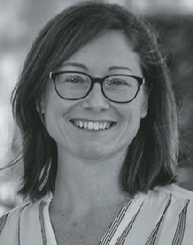
Kate Pain, Clinical Educator – GTK

What is pain and why do we experience it? How does pain limit the ability of people using wheelchairs to achieve
their goals and live the life they want to live?
Chronic pain is a common experience for individuals living with mobility challenges and can often be overlooked when prescribing and assessing assistive technology needs. Understanding our client’s experience is important when
supporting them to achieve their functional and participation goals.
This presentation will explore pain as a barrier to participation, focusing on the unique challenges faced by wheelchair users. We will discuss common causes of pain and how they relate to aspects of the seated position in a mobility device to either enhance or reduce function.

Creating Success: Navigating client expectations, environmental and functional demands. Considering Power Wheelchairs
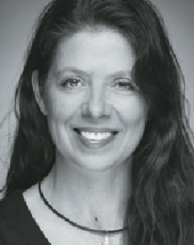
vs Power Add On Devices

Amy Bjornson - Clinical Director - Sunrise Medical
Powered mobility
technology has rapidly evolved in recent years. Now, we have a host of power wheelchairs and powered systems that can be added on to a manual wheelchair. Both are commonly considered as a solution when a manual wheelchair cannot provide the required functional outcomes. This workshop will focus on clinical implications and decision-making process. We’ll look the indications for these technologies
and use objective measures to qualify the technology for your client using case studies to foster learning.

WEDNESDAY 29 MAY 2024
9.15am 45 mins
ROOM 3
ROOM 4

NDIS Rules and Guidelines -
An OT’s Playbook to AT prescription

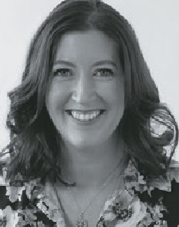
Sarah Collison - Director, Verve OT

Navigating and understanding the NDIS, it’s systems and processes can be
stressful, confusing and send many therapists into a tailspin on the best of days!
Understanding NDIS rules and how they apply to funded supports is essential to AT approval success in the NDIS. The NDIS rules set out the detailed operation of the scheme whilst the operational guidelines explain what the agency considers when making decisions based on legislation.
This session will provide a deep dive into the rules and guidelines most relevant to an OT’s scope of practice to
increase knowledge and awareness when recommending AT funded supports.

Addressing Paediatric Hip Health: Practical Approaches for Positive Outcomes

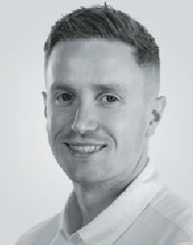
Jamie Cockle - Clinical Educator, Medifab

Navigating the complexities of paediatric hip health is essential when working with children with neurological impairments and disabilities.
This session delves into the prevalent challenges associated with hip joint issues and their secondary complications in this population. We explore the significance of consistent postural support throughout the day and night, coupled with opportunities for weight-bearing and active movement in promoting optimal hip health.
Join to unravel the intricacies of hip development and health within the neurodisability population. The focus extends beyond theory to practical considerations, highlighting the essential balance between 24-hour movement and 24-hour postural care. Gain insights and actionable strategies to make a positive impact, paving the way for a healthier future.

WEDNESDAY 29 MAY 2024
10.30am 30 mins
ROOM 1
ROOM 2

Teamwork makes
the dream work when it comes to complex AT

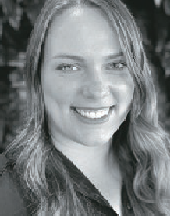
Roseanna Tegel - Clinical Services Specialist – Permobil

It can be confronting as a newer prescriber to understand your role when it comes to
wheelchair prescription,
especially when working in a time poor environment!
Knowing how to work closely with the client, their relevant supports, the
equipment provider, potentially other MDT team members or a manufacturer can be a lot. Utilising each person’s strengths throughout the process however leads to
better outcomes, and often in a faster time.
This session will explore the important role each person has during a complex AT
prescription and empower you as you work closely with the user to identify their unique equipment solution.

Benefits of gel materials in seating

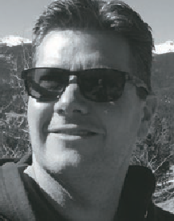
David Fagan - Managing Director, Paragon Mobility

Recent advances in dry polymer gel technology are creating new opportunities for skin integrity management in seating.
Dry polymer gels behave more like a solid than a fluid. They do not migrate, leak, or ooze out of shape, and can be engineered into sheets and columns of different shapes and sizes to offer immersive protection.
They are naturally temperature regulating and vibration dampening – two properties considered important for seating surfaces.
This session will review various seating applications for dry polymer gels, including cushions and other seated support surfaces, bathtubs and bathing equipment, lift chairs, vehicles, and other surfaces.

WEDNESDAY 29 MAY 2024
10.30am 30 mins
ROOM 3
ROOM 4

Deep Dive into alternating air mattresses

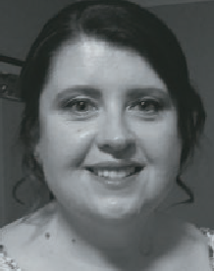
Helen Widdowson and Ankita Peter - Training and Development
Coordinator Qld and NSW – Aidacare
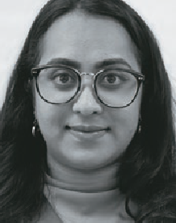
Pressure injuries present a large personal and economic cost across healthcare settings. Alternating
air mattresses are one part of the solution. OTs are increasingly seen as experts in pressure care and often called upon to assess, prescribe
and ensure correct functioning of alternating air mattresses.
For therapists without acute care experience, or therapists working predominantly in other areas of practice, knowledge of pressure care principles and the science behind alternating air mattress is often not established. Knowledge supports clinical reasoning and better outcomes. Therapists will be armed with knowledge on how to qualify pressure care solutions following this presentation.

Options for safely transporting adults and children with disabilities and medical conditions

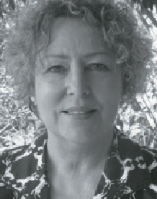
Susan Teerds - CEO Kidsafe Qld and Disability Safe Seating Solutions

What are my choices for safely transporting adults and children with
disabilities and medical conditions in motor vehicles, motor homes, buses and planes.
This presentation will explore the Road Rules, Australian Standards, the use of specialty harness and modified child car restraints. Off-the-shelf car seats can provide great support for low-tone medical needs and also behavioural issues.
Do you need a qualification to modify seats? How do you choose between a harness, a car seat or a wheelchair in a vehicle? What is safer? Who can you ask?

WEDNESDAY 29 MAY 2024
11.15am 45 mins
ROOM 1

Staging Pressure Injuries - Getting it Right

Tracy Nowicki -
Clinical Nurse Specialist

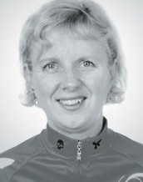
Pressure injuries are localised, avoidable, and mostly preventable.
They are painful, incur significant costs, and are considered a form of
neglect. Accurate staging of pressure injuries
is crucial for proper reporting and, more importantly, for achieving
optimal patient outcomes. By accurately assessing and documenting the pressure injury stage, healthcare professionals can provide appropriate treatment and
implement preventive measures to promote healing and prevent further complications.
This session will explore the following:
- What are the causes of Pressure Injuries?
- Updated Pressure Injury Categories, 4 Stages + 2 Temporary Categories
+ Mucosal Category
- What makes Pressure Injury Stages/ Categories different?
- Why does the mucosal Pressure Injury sit on its own?
- Can you backstage Pressure Injuries?
- What does skin colour have to do with Pressure Injury staging?

WEDNESDAY 29 MAY 2024
11.15am 45 mins
ROOM 2

Made to move - I am

Marcus Thompson - Founder / Inventor Whanauka Limited
INTERNATIONAL SPEAKER

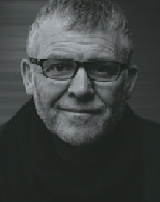
A workshop on the application, use and value of seated balanced based movement technology and how moving with balance can change a life. As seen
through the lens of the Omeo experience and beyond
Join us to learn more about what seated balanced based mobility technology does, how to assess when it should be used and establishing value from the clients perspective with a practical riding component for attendees to align and explore their existing professional knowledge with the findings presented.
People are made to move - it is a core human function. When mobility issues exist, the impact on life goes beyond the obvious challenges of achieving a task, our motivation and sense of self are challenged, without movement through balance our rhythm in life is altered, and in that space we establish or reestablish our identity of
‘I AM’.
It is in this space where good design with smart technology gives us tools of partnership. And in this case ‘seated balanced based movement technology’.
A partnership tool that affords a person to be more whole, should be used by every one - but there are parameters for safe and sustainable use with the products currently available, to establish the suitability for a client requires the assessment of learning and physical capability, fit, motivation, durability, decision making, control, character, logistical support and motivation. For a robust suitability assessment clear trials and an understanding of the functional and performance parameters of the tool / client partnership are required as illustrated by the Omeo Technology trial process and post sale user success.

WEDNESDAY 29 MAY 2024
11.15am 45 mins
ROOM 3
ROOM 4

Big and Brilliant: Accommodating the range of Bariatric shapes for patient handling and positioning.

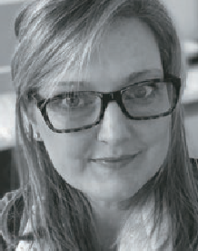
Elissa Coates - National Clinical Education Manager, Novis Healthcare

Each human body is unique in size,
dimensions and weight.
This is no different for clients who are assessed with obesity. Implementing a one size fits all approach to bariatric assistive technology will fail to achieve outcomes such as comfort, reduced risk of adverse events, and encourage maximisation of independence.
In this session we will look at:
- Main somatotypes of the bariatric client body
- Individual movement and positioning needs of each body type
- Shape associated seating requirements
- Implications for provision of assistive technology
By the end of the seminar you will have a more holistic view of the bariatric client to enable you to make informed decisions leading to successful outcomes for
improved quality of life and quality of care.

Cultivating a Dynamic Workforce: Best Practices for Employee Attraction and Retention in the Assistive Technology
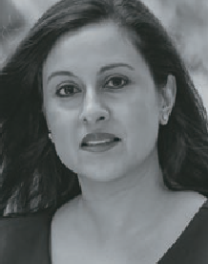
Industry

Joshna Daya and Greg Gunther - Founders and Directors, Your Business Momentum

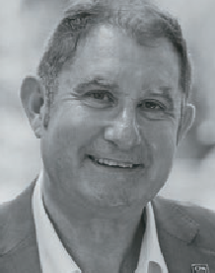
AT suppliers and specialist retailers invest heavily in hiring and skilling up their team, which often include health professionals such as occupational therapists and rehabilitation engineers, who are
essential to ensuring the ‘right fit’ between the person and the AT. But the shortage of skilled professionals remains a persistent concern. The 2021 National Disability Services State of the Sector Report revealed an alarming challenge in staff retention, with a staggering 70% of providers struggling to recruit support workers.
This 45-minute, interactive session is designed for AT business owners and leaders to gain insights on how to effectively attract and retain top talent and leave with a custom one- page plan for immediate implementation.
By attending this workshop, participants will: learn the key success facto rs for attracting and retaining talent, understand the motivations and values of different generations, and discover practical strategies and best practices.

WEDNESDAY 29 MAY 2024
12.00pm 30 mins
ROOM 4

Pressure Mapping Technology

Nabil Kodsi - Clinical Education/ Product Specialist,
Specialised Wheelchair Company

Pressure mapping technology has emerged as a vital tool in the field of wheelchair seating assessment and optimization. There should be a balance between client’s goals and aspirations and Occupational
therapist’s recommendations. Critical thinking constitutes a fundamental aspect of our ability to access quality information and knowledge to form a well-founded opinion or to make informed decision.
By accurately measuring pressure distribution between the body and the wheelchair surface, XSensor Foresite SS enables healthcare professionals to identify and mitigate potential pressure ulcers, a common concern among wheelchair users. Additionally, it aids in optimizing seating posture, reducing discomfort, and preventing musculoskeletal issues associated with prolonged sitting. Through real-time feedback and data-driven adjustments, pressure mapping technology empowers individuals with tailored seating solutions, promoting greater independence, mobility, and overall quality of life for wheelchair users.
This session will explore the application of pressure mapping systems, enhancing the well-being
and comfort of individuals using wheelchairs in combination with OT reflexions regarding what we observe, assess, and understand.

WEDNESDAY 29 MAY 2024
1.00pm 45 mins
ROOM 1
ROOM 2

NDIS
Dr Lloyd Walker

Paediatric Panel -
come prepared with your questions to ask the Panel

MODERATOR: Robert Norman – National Educator, RTD
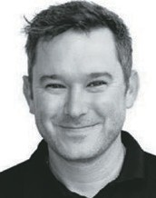
This fully interactive session answering your questions and challenges in a big world of Paediatrics.

WEDNESDAY 29 MAY 2024
1.00pm 45 mins
ROOM 3
ROOM 4

The Impact of Lying, Sitting and Positioning on Respiratory System Function

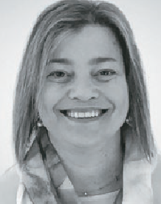
Lois Brown & Sarah Uncle (Clinical Educator) - National
Clinical Education Manager at ILS

This session will help you keep respiratory function in the forefront of your mind when
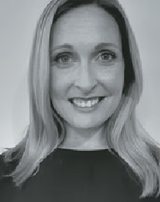
you are assessing and applying equipment solutions in lying
and sitting. Knowing the biomechanics of breathing and how that is affected by a client’s position is critical for all clients.
We might see ‘optimal posture’, but a respiratory therapist may see an overly restricted abdomen and chest wall. It is imperative we have enough general
knowledge and awareness of respiratory function to ensure our efforts do not compromise our patients breathing.

Changes to the building code and the impact on home modifications

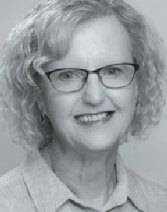
Jane Bringolf - Chair, Centre for Universal Design Australia

The Liveable Housing Standard is now
part of the National Construction code and
Queensland has adopted it. The Standard provides for basic access features in all new homes and extensively modified or renovated homes.
These features are equivalent to the Silver level of the Liveable Housing Design Guidelines. Level entry to the home, a step- free shower, reinforcement of walls in the bathroom, and wider doors and corridors are the key elements.
So, what will it mean for the AT and home mods sector? This presentation will discuss the Standard and the implications for home mods and related AT.

WEDNESDAY 29 MAY 2024
2.15pm 30 mins
ROOM 1
ROOM 2

Prescriber confidence in complex wheelchair seating: introducing a new digital platform to support clinicians

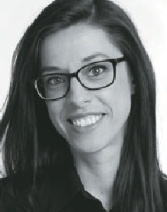
Joana Santiago - Head of Clinical Education and R&D Clinical Lead & Ed Milner Clinical Educator, Medifab

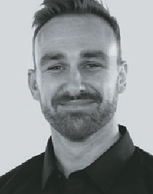
Wheelchair seating provision can be a complex process, requiring detailed assessment and consideration of numerous variables. Analysis of recent education feedback indicates that therapists often cite a “lack of
confidence” when assessing their clients’ mobility and seating needs, and struggle to translate their assessment findings into product requirements and features.
With that in mind, this new digital
platform has been designed to equip therapists, rehab engineers and seating product specialists with a tool to support the step-by-step physical examination process. Users can store individual client data securely, providing a log for assessment findings over time in a password protected environment. Body measurements and postural support needs can be inputted and then transferred into a 3D model, providing visualisation
of client presentations that can be shared among stakeholders involved in the prescription process. With clearer understanding of client presentation alongside digital representation of assessment findings, product selection and configuration can ultimately be improved.
This presentation will provide live access to all attendees and will demonstrate features and opportunities for therapists to be thorough, increase their confidence
and support their clinical reasoning process to achieve successful clinical outcomes.

Bums, Bowels, and Bladder: Plane travel and things to consider for wheelchair users

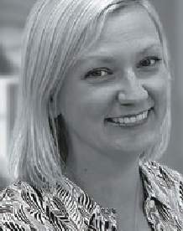
Tilly Brook
- Clinical Education Specialist, Permobil Asia-Pacific

What main
things do wheelchair users need to consider prior to plane travel and what supports
are out there to assist? How do we make sure pressure care needs are met on long- haul flights and how can wheelchair users safely complete their
bladder and bowel care 30,000 feet high?
This presentation will review current EBP with reference to best practice guidelines for pressure care and bladder and bowel management and dive into practical solutions to ensure this can be completed on a plane.

WEDNESDAY 29 MAY 2024
2.15pm 30 mins
ROOM 3
ROOM 4

TD Access Suite - Improved eye gaze access to distance communication, web browsing and phone functions.

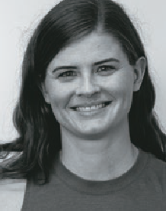
Natalie Stehbens - Assistive Technology Consultant (Occupational Therapist)

Internet, phone and computer access is
vital for independence, social connection, employment and learning. In this session we will introduce a suite of new software applications specifically built to make eye gaze access to these functions simple, familiar and easier to use.
The TD Access Suite includes TD Browse, a built-for-eye gaze web browser, TD Phone, which provides easy to set-up access to
all phone functions via eye gaze, and TD Control which allows for comprehensive and intuitive mouse control of a Windows environment.
We will also discuss how these functions can be used as an engaging introduction to eye tracking.

Applying evidence-based practice when assessing
and prescribing for children’s car seating needs

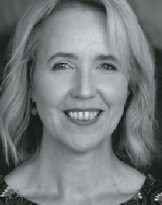
Helen Lindner, Chief Executive, MACA

MACA is leading an unprecedented research and work program which is building a new
evidence base for allied health professionals supporting the motor vehicle transport
of children with disabilities and medical conditions.
This includes work conducted by MACA’s Australian Safety Assessment Program; a large-scale research project investigating specialty harnesses/vests; the development of specialist training courses; and research led by Neuroscience Research Australia investigating child restraint modifications. There are also some new developments in key standards and regulations relating to transporting children with disabilities and medical conditions.
MACA Chief Executive Helen Lindner will share some of these exciting new findings and developments. Discover how you
can apply evidence-based practice in this rapidly evolving research, standards, and legislative environment.

WEDNESDAY 29 MAY 2024
3.15pm 45 mins
ROOM 1
ROOM 2

Occupational Therapy Australia panel session – The role of occupational therapists in AT provision
The Wheel Story -
The Impact of Wheels and Tires on Manual Wheelchair Propulsion Efficiency

David Fagan - Managing Director, Paragon Mobility

Selection and set up of wheelchair wheels and tyres dramatically influence performance
and propulsion efficiency. This presentation addresses the science and current research findings on wheelchairs and tyres.
The presentation will cover materials and design, characteristics of drive and castor wheels that impact efficiency, the
importance of wheel diameter as it relates to rolling resistance, and the influence of rotational inertia in manual wheelchair propulsion. Practical considerations for wheel and tyre selection, such as ongoing maintenance needs, will also be discussed.

WEDNESDAY 29 MAY 2024
3.15pm 45 mins
ROOM 3
ROOM 4

Exploring the Potential: Maximising Independence Through Electronics in Complex Power Wheelchairs

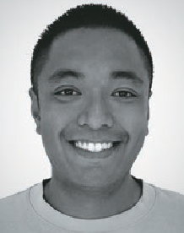
Andrew Lopez - Product Specialist & Clinical Educator – Quantum Rehab

Complex power rehab wheelchairs have some of the most advanced
electronics in the complex rehab industry. Maximising a user’s independence should always be the goal of the team providing the wheelchair to the individual.
Despite being a valuable tool, Bluetooth is a vastly underutilized technology that most manufacturers have built into the expandable electronics.
This seminar will focus on the power of Bluetooth technology and how we can combine this with smart technology that is readily available on the market to maximise independence within an individual’s environment.

On the Road Again: Transport Considerations Across the Lifespan

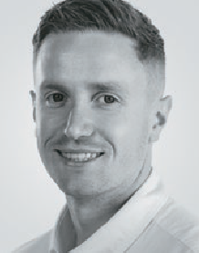
Jamie Cockle - Clinical Educator, Medifab and Omid
Akbarian - Solutions Specialist, Mobility Engineering

Discover the importance of personalised transport solutions
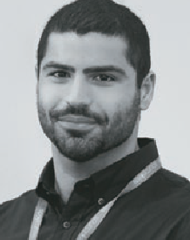
for individuals with medical conditions and disabilities, addressing safety, well-being, and comfort concerns. In this informative session, we delve into the inadequacies of off-the- shelf products designed
for ‘typically developing’ children through to adults and emphasise the need for specialised options that cater to the unique requirements of individuals throughout their lifespan.
Our journey spans from infancy to adulthood, highlighting specific focus areas for each age group. Once armed with an understanding of transport plans, we shift our focus to practical solutions within the realms of Car Seats, Vehicle Seat Positioning, Transfers, and Wheelchair Access.
This session will explore how personalised transport solutions can promote a lifetime of safety, comfort, and well-being for individuals with disabilities, transforming travel experiences at every stage of life.

THURSDAY 30 MAY 2024
7.30am 90 mins
ROOM 1

Know your way around standing frames. A practical session measuring for both fitting and growth.
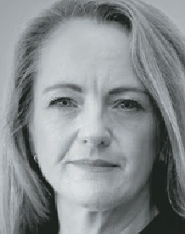
Mellinda Fitzgerald
- Clinical Educator - APEX Mobility and Robert Norman, National Educator, RTD
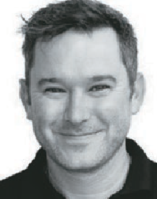

THURSDAY 30 MAY 2024
9.15am 45 mins
ROOM 1
ROOM 2

The 6 P’s For Success Supporting Fixed Postures – A case study

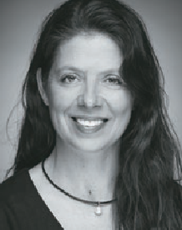
Amy Bjornson - Clinical Director - Sunrise Medical

This session walks through the steps of consideration and compromise when translating postural
assessment findings into a functional seating and mobility prescription for our more complex clients.
We’ll provide practical tips and ideas during the decision-making process: how to simulate postural supports, how to ready yourself for a successful equipment trial with the supplier and the client.

Finding Balance: Creating functional stability for wheelchair users

Jacelyn Goh - Occupational Therapist | Clinical Educator | Product Specialist, Linds Rehabilitation

Take it from an experienced wheelchair seating clinician, the
hardest wheelchair users to provide postural supports for are the ones who move!
Any therapist prescribing wheelchairs will confidently tell you that we must start at the pelvis! But do we truly understand what it means to create a stable base support?
What happens to the base of support when the wheelchair user moves in and out of positions to function? What components on the wheelchair frame and seating system can we use to enhance participation for the individual?
This session will take you on a journey through the assessment process to make our client centered outcomes match the features we prescribe in available product

THURSDAY 30 MAY 2024
9.15am 45 mins
ROOM 3

Why ‘nearables’ will soon overtake ‘wearables’ in the smart bedroom!

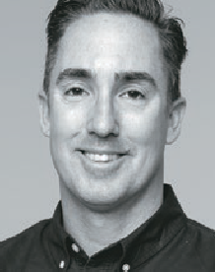
Cameron van den Dungen - Founder & CEO -
Sleeptite

For over 15yrs, Cameron van den Dungen has travelled the world searching for innovation and technology in sleep
science and research focused on ‘what is next’ for the sleep industry, and how the bedroom can evolve as part of the smart home, hospital, barracks, or boarding school. Cameron uncovered gaps in the quality of the data collected by existing sensors as well as limitations in the application of existing technologies.
In this session, Cameron will discuss why ‘nearable’ technology promises to deliver far better outcomes for the individual and their support networks in assisted living settings.

THURSDAY 30 MAY 2024
10.15am 30 mins
ROOM 1
ROOM 2

Solving mental and physical health challenges through adaptive fashion!
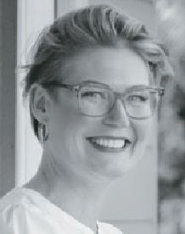
Jessie Sadler, CEO & Founder and Carol Taylor, Partner,
Head of Design & Production -
Christina Stephens

Christina Stephens is Australia’s most recognised adaptive
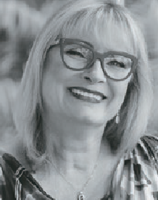
clothing label. Adaptive clothing is estimated
to be worth over $400 billion globally in 2023. In Australia adaptive clothing is fully NDIS and HCP fundable and is considered an assistive technology.
The mental health benefits of inclusive fashion cannot be underestimated. Being ‘seen’ and ‘heard’ and able to express your individual self is paramount to positive mental health outcomes.
Through lived experience we understand the physical risks that disabilities may present, such as temperature regulation, sensory challenges and deadly pressure sores.
Approximately $9 billion is spent in Australia annually on pressure sores, of which $3.5 billion goes directly into treatment.
The vast mismatch between prevention and treatment has been a healthcare blind spot, a gap that we are helping to bridge through our innovative adaptive clothing designs.

A guide to prescribing specialist seating solutions: 10 essential things to know

Bianca Brady - Clinical Education Co-Ordinator, APEX
Mobility

Posture care is an essential intervention for individuals facing challenges in achieving safe and independent
posture/s for function and engagement. Unlocking the potential benefits of a specialist seating solution beyond the wheelchair can significantly impact health and well-being. Nevertheless, identifying the right starting point and effectively addressing this need can be overlooked or prove challenging. This session aims to empower clinicians with a guide, including key considerations for successfully implementing a specialist seating solution beyond the wheelchair.

THURSDAY 30 MAY 2024
10.15am 30 mins
ROOM 3

Suspension and Motors – Hidden, but not Forgotten.

Tilly Brook -
Clinical Education Specialist - Permobil Asia-Pacific

Suspension and motors are hidden under the shroud of a Power Wheelchair (PWC),
but out of sight should not mean out of mind.
In fact, the motor and
suspension of a PWC have significant implications on function – where a person can go and how they feel when they get there.
After this session, you will feel more confident when considering the elements under the shroud of a PWC: how they can differ between chairs and what questions to ask to match it to your client’s needs and goals. What is under the shroud should never be an afterthought!

THURSDAY 30 MAY 2024
11.00am 45 mins
ROOM 1
ROOM 2

Matching the Levels of Mobility Impairment to AT Solutions: Establishing Positive Client Outcomes

Lois Brown - National Clinical Education Manager, ILS

We all have referrals for clients with varying degrees of physical
mobility impairment and hidden disabilities which limits their activities and participation in their daily lives. The assessment process and equipment prescription is about matching those needs to the body structure and function (postural seating needs) while taking into consideration environment of use. A mobility algorithm can guide us in the prescriptive process, ensure a positive person-centered outcome and help in our funding applications. There are a lot of factors to consider in determining the need in moving from one category of mobility aid to another, and this session will help you do just that.

Are We Satisfied With Current Seating Technology Outcomes Or Should We Strive To Achieve More?

Filipe Correia - Latin America and Europe, Business Development Manager, Stealth Products, LLC
INTERNATIONAL SPEAKER
Seating systems providing wheelchair users with PSIS, and lumbar support and back support reclining systems are
common practice when dealing with seating challenges such as postural fatigue, user discomfort and passive seating and sliding. While PSIS, lumbar support and back support recline systems can provide many benefits to wheelchair users, there are limitations to consider.
This presentation will provide an in-depth biomechanical analysis of the outcomes of PSIS, lumbar support and back support recline interventions and will illustrate
the limitation of such interventions using case studies. In addition, the benefits of an alternative seating approach whereas independent and dependent adjustments for postural changes for function, absorption of repetitive loading and for low shear seating interventions will be discussed.

THURSDAY 30 MAY 2024
11.00am 45 mins
ROOM 3

Seating Support beyond the Wheelchair: A Closer look at Paediatric Adaptive Seating

Mellinda Fitzgerald - Clinical Educator,
Physiotherapist - Apex Mobility

Supported seating is a valuable part of the postural management
programme for children
and young people with physical disabilities, with the aim of helping to maintain or improve body structures and function, increase activity and participation levels, and promote quality of life.
Adaptive seating can however look very different outside of the wheelchair, with differing aims and goals at times as compared to wheelchair seating.
This session will explore key considerations and practice guidelines when making decisions about alternative adaptive seating, incorporating both early intervention approaches and the support of complex postures, with the aim of building confidence in prescription for clinicians.

THURSDAY 30 MAY 2024
1.00pm 30 mins
ROOM 1
ROOM 2

Adaptive Clothing Fashion Show
Wheelchair solutions for tricky clients – when “typical” solutions just won’t work

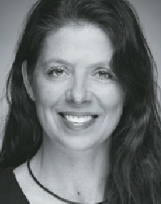
Amy Bjornson - Clinical Director - Sunrise Medical

This case study-based workshop will explore our practices in seating and wheelchair provision.
We will discuss the
‘optimal’ wheelchair for a given client doesn’t meet their needs or their goal set. When that typical wheelchair solution is not possible, we must have a plan B.
We will investigate what can be considered as appropriate compromises, how to have discussions with clients and stake holders to reach a happy compromise. Following this session, you’ll feel more confident in translating your assessment findings into workable, successful prescriptions.

THURSDAY 30 MAY 2024
1.00pm 45 mins
ROOM 3

Assistive Technology (AT) in Australia: Current
opportunities and challenges for the AT sector

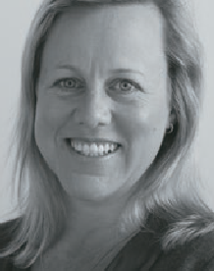
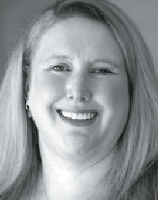
A/Prof Libby Callaway - 2024 Strategic Executive Advisor and Dr Melanie Hoyle - 2024 President, Australian Rehabilitation and Assistive Technology Association (ARATA)
Australia continues to undergo major reforms across health, ageing and disability. These reforms are significant for both people who
use Assistive Technology (AT), as well as those who advise on, develop or supply AT. This presentation by the Australian Rehabilitation and Assistive Technology Association (ARATA) – a national peak body for AT stakeholders – will outline current opportunities and challenges in the Australian AT sector, and link these to both national and international AT policy.
Information resources and strategies to inform both consumer and service provider experiences of AT products, provision, personnel and policy will be detailed.
Recommendations for further action in the AT sector will be discussed.

THURSDAY 30 MAY 2024
2.00pm 45 mins
ROOM 1
ROOM 2

Pressure and Posture in Lying: A Vital Duo Often Overlooked

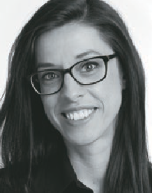
Joana Santiago, Head of Clinical Education at Medifab and Sarah Uncle, Clinical
Educator at Independent Living Specialists
Clients with complex and continuing healthcare needs face a silent,
ongoing battle—unseen changes in body shape and increased risks of pressure injuries when lying. This can happen slowly over a long period of time and may affect a person who has difficulty moving efficiently, irrespective of diagnosis or age.

This session provides you with strategies to protect clients from the risks of static, destructive postures while protecting their skin. Pressure care principles, support surface selection and therapeutic positioning systems will be discussed.
Grounded in the latest clinical evidence and international guidelines, this session prompts a re-evaluation of current practices.

Mobile Shower Commode Chairs for people with larger bodies

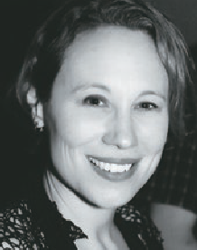
Emma Friesen - Product Portfolio Manager, Paragon Mobility

People with larger bodies may experience challenges in undertaking activities
such as toileting, intimate hygiene, and bathing. They may need AT – specifically mobile shower commode chairs (MSCCs) - with higher weight capacities and size, and that require greater circulation spaces in the physical environment.
This workshop will focus on assessment, selection, specification, and set up of these MSCCs. The workshop will include an overview of Dionne’s five bariatric body types, tips for optimizing seating and postural support, and discuss clinical justification for various options and accessories.

THURSDAY 30 MAY 2024
2.00pm 45 mins
ROOM 3

“It isn’t working”:
Exploring options once a wheelchair has been delivered

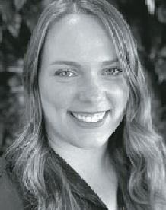
Roseanna Tegel - Clinical Services Specialist - Permobil

Whether you were the original prescriber or have just met the client, conducting regular seating and
wheelchair reviews can be complex with psychosocial, best-practice, time-restraints, and cost considerations. If then, you hear the dreaded “it isn’t working” relating to a cushion, wheelchair or even a key accessory, it can be overwhelming to know what to do.
Join us as we explore the when, the why and the how of wheelchair reviews to empower the user to maximise their AT outcome. We will also explore the importance of wheelchair reviews,
including the frequency and key things to look out for.

THURSDAY 30 MAY 2024
Special Event
Centre for Universal Design Australia presents a Symposium:
CONNECTING PEOPLE AND PLACES WITH UNIVERSAL DESIGN: QUEENSLAND LEADING THE WAY

THURSDAY 30TH MAY FROM 9AM TO 12.30PM BRISBANE CONVENTION CENTRE
COST $50 + GST
The aim of the symposium is to develop recommendations for raising the presence and profile of universal design and inclusion in the legacy of the Brisbane 2032 Games
The half day format will be a speaker panel with representatives from housing, transport, and tourism followed by small group work on framing recommendations. The recommendations will contribute to the implementation of Queensland’s key strategy Elevate 2042 Games Legacy Plan.
This symposium will be of interest to urban and regional planners, practitioners involved in liveable cities, sports administrators, advocacy groups, and anyone who is interested in creating an inclusive Queensland.

