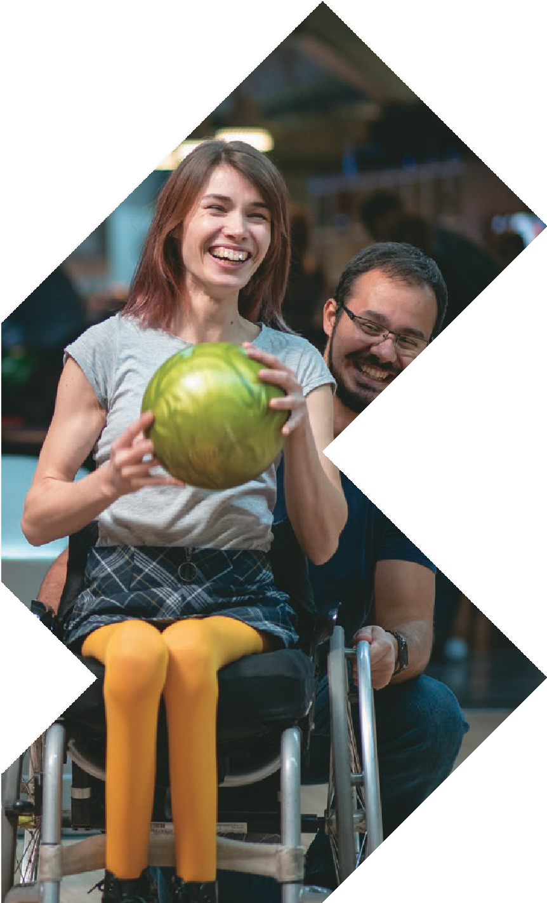
ADELAIDE
6-7 MARCH 2024
ADELAIDE SHOWGROUND
Goodwood Road, Wayville, SA

SEMINAR PROGRAM

OPENING HOURS
Wednesday 6 March 8:30am – 4:30pm
Thursday 7 March 8:30am – 3:00pm

events@atsa.org.au www.atsaindependentlivingexpo.com.au

Organised by Media Partners

WEDNESDAY 6 MARCH 2024
9.00am 45 mins 9.00am 45 mins
ROOM 1
ROOM 2

The 6 P’s For Success Supporting Fixed Postures – a Case Study.

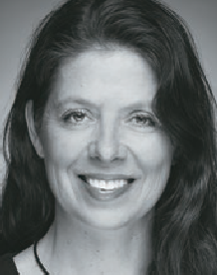
Amy Bjornson, Clinical Director - Sunrise Medical

This session walks through the steps of consideration and compromise when translating postural assessment findings
into a functional seating and mobility prescription for our more complex clients. We’ll provide practical tips and ideas during the decision-making process: how to simulate postural supports, how to ready yourself for a successful equipment trial with the supplier and the client.

Restrictive Practice implications in
AT Assessment

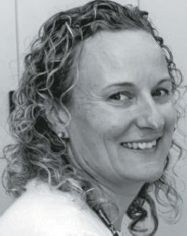
Belinda Carpenter, Occupational Therapist
and Assistive Technology Practice Lead - Novita
Assistive technology can, at times become a
Restrictive Practice (RP) and is sometimes necessary for safety and wellbeing. There are steps that need to be taken in order to ensure that the safest and least restrictive option is put in place. Working closely with Positive Behaviour Practitioners is key, as is clear documentation.
At other times, AT can be misinterpreted as being an RP or it can be unclear about whether it is or could be seen as a RP. This session will discuss how to determine this and what are reasonable steps in the assessment process.”

WEDNESDAY 6 MARCH 2024
9.00am 45 mins
ROOM 3

Standing tall for health and participation

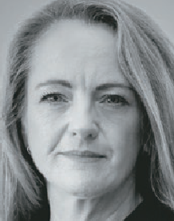
Mellinda Fitzgerald, Clinical Educator - APEX Mobility

Supported standing for children and adolescents with physical disabilities has many health benefits that can deliver positive outcomes to promote quality of life.
However, there are many considerations and key practice guidelines that need to be addressed to allow us to understand this entirely.
This session will focus on highlighting the benefits of standing and the key practice guidelines needed to work towards these. Considering both approaches of early intervention and planning for challenging postures, the session then takes a closer look at how prescribers and all stakeholders work together to achieve standing goals to promote function and participation.

WEDNESDAY 6 MARCH 2024
10.15am 45 mins 10.15am 45 mins
ROOM 1
ROOM 2

Improving AT outcomes by strengthening the collaboration of the AT supplier and therapist

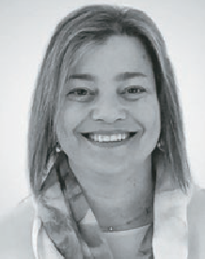
Kim Vien - Senior Occupational Therapist, Royal Melbourne Hospital, Wheelchair and Seating Clinic & Lois Brown - National Clinical Education Manager, ILS
Working relationships are formed when developing Assistive Technology solutions for people
with disabilities. This session will delve into
the relationship formed by AT suppliers and prescribing therapists. It will explore the roles of each party, the strategies to improve communication between each
other and how this working relationship can get the best AT solutions for our clients.
Lois and Kim will present some case studies, examples of templated documents therapists can use and discuss how to approach scripting when there is inequity with experience. This session will benefit new therapists and AT suppliers entering the Assistive Technology space.

Bringing lie flat child restraints to Australia

Helen Lindner –
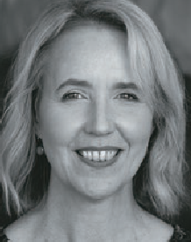
Chief Executive, MACA

Some children with conditions like spinal muscular atrophy, sleep apnoea and respiratory challenges are unable to be transported safely in a recline position
in vehicles. In some
cases, lie-flat child restraints can offer improved support for these medically vulnerable children and enable families to independently get out and about with their child.
Alarmingly, unlike many other countries, Australia has not had access to lie-flat child restraints.
MACA will discuss how an innovative and collaborative approach, with funding support from the Transport Accident
Commission, enabled the establishment of a holistic model for the supply, safe and legal use of lie-flat child restraints for Australia

WEDNESDAY 6 MARCH 2024
10.15am 45 mins
ROOM 3

Implementing postural care in the real world

Prithy Sivaraman, Physiotherapist, Clinical Hub - Sunrise Medical

This session will provide an overview of around the clock positioning considering the complexities of balancing comfort, function and stability.
Whilst the concept of a postural care management plan can be daunting for those who have to put it in action, we’ll consider how to introduce this is practically. The focus will be on translating clinical principles to realistic ideas in order to
break the cycle of asymmetry. With a holistic approach we can help identify strategies throughout the day that can be implemented for our individual clients.

WEDNESDAY 6 MARCH 2024
11.15am 45 mins 11.15am 45 mins
ROOM 1
ROOM 2

Consumer assistive technologies and AI:
a benefit or a curse?

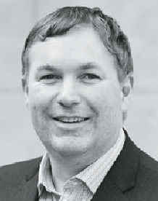
Dr Scott Hollier, Centre For Accessibility Australia

In recent times we’ve seen significant improvements in assistive technologies built into our everyday devices,
and many of these are thanks to generative AI such as live captioning and the use
of automated voices to support people who are non-verbal. Yet at the same time these technologies are providing benefits, systems are also removing their use for privacy and security reasons.
What tools can we use, and what can be done to ensure we maximise digital access going forward?
Dr Scott Hollier from Centre For

Paediatric Panel -
come prepared with your questions to ask the Panel

MODERATOR: Robert Norman – National Educator, RTD
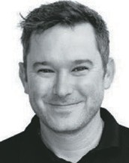
This fully interactive session answering your questions and challenges in a big world of Paediatrics.

PANELISTS:

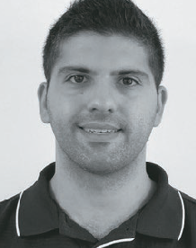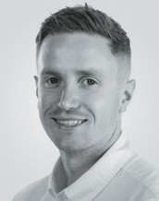

Accessibility Australia will share his insights.
Amin Akbarian – Mobility Engineering
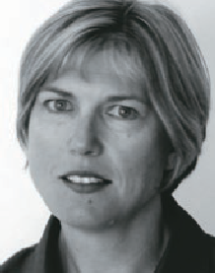
Simone Fejer - Ils Kids (PAFL)
Jamie Cockle – Medifab

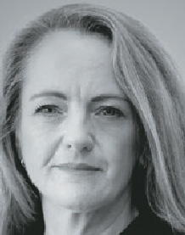
Mellinda Fitzgerald
- Apex

WEDNESDAY 6 MARCH 2024
11.15am 45 mins
ROOM 3

Deep dive into alternating air mattresses
Ally Lavalle-Smith and Ankita Peter,
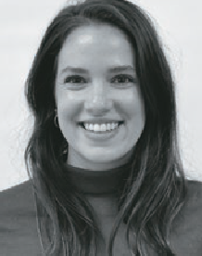
National Training Manager and Training and development
Co-ordinator - Aidacare
Pressure injuries present a large personal and economic cost across healthcare settings. Alternating
air mattresses are one part of the solution. OTs are increasingly seen as experts in pressure care and often called upon
to assess, prescribe and ensure correct functioning of alternating air mattresses.
For therapists without acute care experience, or therapists working predominantly in other areas of practice, knowledge of pressure care principles and the science behind alternating air mattress is often not established. Knowledge supports clinical reasoning and better outcomes. Therapists will be armed with knowledge on how to qualify pressure care solutions following this presentation.

WEDNESDAY 6 MARCH 2024
1.00pm 45 mins 1.00pm 45 mins
ROOM 1
ROOM 2

NDIS (TBC)
Building the manual wheelchair: Foundations for promoting function and efficiency

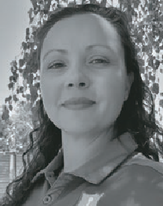
Lauren Kerr and Bianca Brady Director of Clinical Education / Clinical Education Co-Ordinator
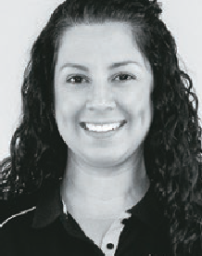
When selecting an appropriate manual wheelchair, we often focus on the features and benefits of the selected product, or default to
the familiar. To consider our client’s unique goals, needs, and wants we
need to ensure that we fully understand the form and function of the wheelchair selected.
Design and material science play a role in functional performance and efficiency and this session will review how frame style, material and component selection of the final wheelchair can impact user health and well-being.

WEDNESDAY 6 MARCH 2024
1.00pm 45 mins
ROOM 3

Optimising a wheelchair: strategies to achieve optimum results for every end user

David Fagan - Managing Director, Paragon Mobility

Professionals involved in manual wheelchair provision work closely with end users to create configurations
that achieve optimum results for comfort, postural stability, function and propulsion efficiency.
This presentation will explore details of wheelchair set up factors known to optimise these outcomes, such as horizontal and vertical axle positions.
The presentation will also review current research on wheelchair optimisation, discuss the importance of making prescriptive decisions while still providing for potential changes in clinical need, and the value of implementing follow up plans to reoptimize the wheelchair over time.

WEDNESDAY 6 MARCH 2024
2.00pm 30 mins 2.00pm 30 mins
ROOM 1
ROOM 2

Staging Pressure Injuries- Getting it Right

Tracy Nowicki,
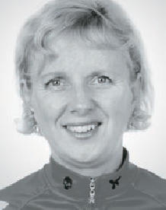
Clinical Nurse Consultant

Pressure injuries are localised, avoidable, and mostly preventable. They are painful, incur significant costs, and are considered a form of neglect. Accurate staging of pressure
injuries is crucial for proper reporting and, more importantly, for achieving optimal patient outcomes. By accurately assessing and documenting the pressure injury stage, healthcare professionals can provide appropriate treatment and implement preventive measures to promote healing and prevent further complications.
This session will explore the following.
- What are the causes of Pressure Injuries?
- Updated Pressure Injury Categories, 4 Stages + 2 Temporary Categories + Mucosal Category
- What makes Pressure Injury Stages/ Categories different?
- Why does the mucosal Pressure Injury sit on its own?
- Can you backstage Pressure Injuries?
- What does skin colour have to do with Pressure Injury staging?”

Facilitating functional reach with power wheelchairs

Tracee-lee Maginnity,
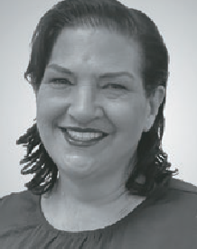
Permobil Clinical Services Specialist

Power mobility base users often do not have the strength or shoulder stability to functionally mobilise a manual wheelchair.
When scripting manual wheelchairs, emphasis
is around maximising function and prevention of future shoulder injuries. This is an important consideration, as we know inappropriate configuration can impact shoulder health. We also know functional tasks of ADLs such as reaching and transferring can place additional stress on this important joint when performed in a seated position.
Are we placing the same emphasis around maximising function whilst still protecting the shoulders when scripting power bases? What do we need to consider around reaching from a seated position? How does shoulder integrity impact reach?
After taking a deeper look at the shoulder and upper limb requirements in relation to specific task analysis, this session will look at functional reach of the upper extremities for powered mobility base users and how AT features can support and maximise functional outcomes.

WEDNESDAY 6 MARCH 2024
2.00pm 30 mins
ROOM 3

How Technology is Increasing the Independence of Young People with Spasticity

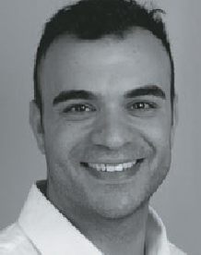
Jonathan Fragale & Luke Gordon NeuroMobility Business Development Manager

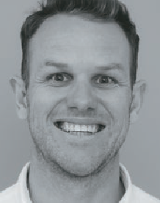
Spasticity and it’s sometimes unpredictable nature, can impede
a person’s ability to achieve a degree of independence. It is our obligation as disability care providers to utilise science-based technology available to us to maximise our
patient’s chance of independence.
Fortunately, advancements in technology over the recent years are beginning to make the goal of independence easier to achieve. Technologies such as wheelchair design and modifications, different forms of electrical stimulation and orthotic design and materials.
Join Jonathan Fragale and Luke Gordon from Ottobock Australia as they do a deep dive into the fundamental principles behind these technologies.

WEDNESDAY 6 MARCH 2024
3.00pm 45 mins 3.00pm 45 mins
ROOM 1
ROOM 2

The Physical and Psychosocial benefits of playing wheelchair sport and how to fund equipment

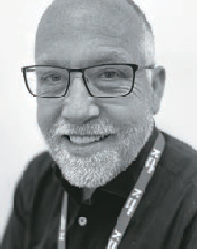
Wayne McNamara Novitatech

Do you ever talk about wheelchair sport with your clients, or have you considered it for yourself?
Find out why you should
and learn how wheelchair sport can improve your life, or that of your clients. Discover the surprising benefits that arise and how what you do on a court or track, transfers to life away from it. Realise the social and physical benefits you achieve being surrounded and encouraged by like-minded people that will give you confidence and improve your life
Equipment can be the biggest roadblock to people starting wheelchair sport so we will discuss some tips about how NDIS funding can give you access to these.
Discover different ways you can get funding for equipment with other less known opportunities outside of the NDIS.
Wayne is a 4-time Wheelchair AFL National Champion and currently plays for Norwood in the Wheelchair SANFL. He has worked
in Assistive Technology for 14 years and has spent much of that time dedicated to helping people through the benefits of wheelchair sport.
AUSTRALIAN RECORD ATTEMPT
After this session join Wayne as he leads a wheelchair conga line in an attempt to break the current Australian record.

Alternative Access to Computers and Devices

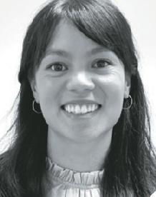
Caitlin Mah, Occupation Therapist, Zyteq Pty Ltd

If the standard keyboard and mouse, or touch screens are difficult to use, alternative access to computers, tablets and devices can ensure ongoing operation and
control. A selection of the current range of mouse alternatives including head- tracking devices and eye-gaze will be demonstrated and evaluated in relation to user application. Parameters to be
considered are overall efficiency of access, range of movement, accessibility settings, device platform and client suitability.
As Zyteq’s Occupational Therapist, Caitlin assists our clients to select the technology that best suits their needs, starting with working together to explore the most suitable access method or methods in the context of the individual’s goals.
Caitlin has worked with a range of individuals of differing abilities and diagnoses in Canada and Australia, and she continues to expand her skillset through her clinical practice and professional development. Caitlin aims to positively contribute to the field of occupational therapy by enabling consumers to find personal meaning and satisfaction in the occupations that make them unique and contribute to their wellbeing.

WEDNESDAY 6 MARCH 2024
3.00pm 45 mins
ROOM 3

The Why, When, and How of Night-time Positioning

Joana Santiago,
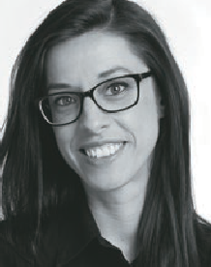
Head of Clinical Education

Poor postural care can have severe and life-threatening
complications for people who have a limited ability to change position.
Asymmetric posture, combined with the force
of gravity, impact on body shape negatively and can be linked with the development of postural deviations.
There is a growing body of evidence demonstrating that night-time positioning is beneficial to people with mobility impairment, particularly when considered as part of a 24-hour postural management program.
In this session we will support clinicians with their clinical reasoning around client needs, goals and benefits and will highlighting crucial steps and considerations to reference throughout the process. A practical and useful tool will be provided to assist with data collection.

THURSDAY 7 MARCH 2024
9.00am 45 mins 9.00am 45 mins
ROOM 1
ROOM 2

Supporting children safely for travel, addressing postural support needs in available special purpose car restraints

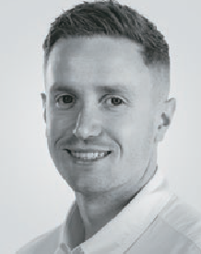
Jamie Cockle Clinical Educator, Medifab

Car travel can be exciting, providing us with a sense of
freedom and access to
our community and beyond! For children with disabilities and their families however, the right piece of equipment can be the difference between safe and unsafe access to vehicle transportation. Whether its inner city driving for visits to therapy centres,
or long commutes from regional areas for specialist assessment or intervention,
children with disabilities can spend a long time in a vehicle.
For those with limited postural control, travel can be stressful and dangerous without the right support. Whilst “off the shelf” car seats provide some support for occupants, for children with less postural control this may be insufficient.
This presentation will outline the challenges associated with poor postural control particularly as it relates to travel. We will discuss the pro’s and con’s of different options available in the market to support children and discuss the clinical applications for assessment and intervention.

An Alternate Route to Independence - Clinical Considerations for Alternate Drive Controls on Powered Wheelchairs

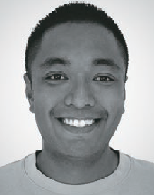
Andrew Lopez, Clinical Educator
- Pride Mobility / Quantum Rehab

Help! My participant wants to control their wheelchair
independently, but has limited to no hand control and can’t drive with a traditional joystick.
In this presentation, we will delve into the realm of Alternate Controls - What they are and the essential considerations for implementing them for powered mobility. As healthcare professionals and clinicians, understanding the clinical aspects of alternate drive controls is crucial for facilitating effective and personalised mobility solutions that empower users to achieve greater autonomy. We will cover topics such as:
- What are Alternate Controls?
- Assessment and Functional Capacity
- Difference Between Proportional and Switch Inputs
- Alternate Control Solutions
- Training and Skill Development

THURSDAY 7 MARCH 2024
9.00am 45 mins
ROOM 3

Navigating Sensory Worlds: Understanding and Supporting Autistic Sensory Needs

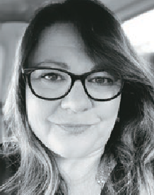
Anita Ahern

Embark on a profound exploration of sensory sensitivities in autism through my lived experiences as a
carer, neurodivergent individual, and founder of Australia’s first national autism directory.
Go beyond theory and discover practical strategies designed to create environments that are not only inclusive but also safe for neurodivergent individuals. Address the challenges that often accompany sensory sensitivities and gain valuable insights to empower both autistic individuals and their parents and carers.
This presentation seeks to navigate the unique sensory worlds in a safe, neuro- affirming manner, offering a collaborative approach to fostering understanding and support within our community.

THURSDAY 7 MARCH 2024
10.00am 30 mins 10.00am 30 mins
ROOM 1
ROOM 2

Applying seating knowledge to Mobile Shower Commode Chairs

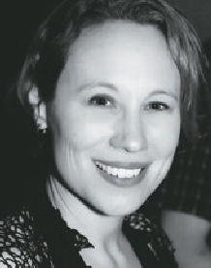
Emma Friesen, Product Portfolio Manager, Paragon Mobility

For some people, activities of daily living such as toileting, intimate hygiene, and bathing /
showering, require use of mobile shower commode chairs (MSCCs). These activities involve a range of functional tasks including undressing and dressing, getting onto and off the toilet, positioning and repositioning, managing bowel movements, passing
urine, maintaining personal hygiene, and managing menstruation.
Seating in MSCCs requires balancing this functioning with managing three additional seating-related goals: pressure and skin integrity, posture, and comfort. The presentation draws on participants’ existing knowledge of seating for wheeled mobility and other sitting surfaces and applies it to MSCC seating.

TD Access Suite - Improved eye gaze access to distance communication, web browsing and phone functions.

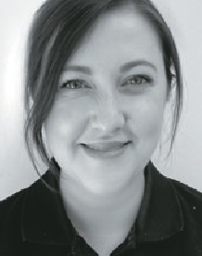
Jade Bilusich Assistive Technology Consultant (Occupational Therapist)
Internet, phone and computer access is
vital for independence, social connection, employment and learning. In this session we will introduce a suite of new software applications specifically built to make eye gaze access to these functions simple, familiar and easier to use.
The TD Access Suite includes TD Browse, a built-for-eyegaze web browser, TD Phone, which provides easy to set-up access to
all phone functions via eye gaze, and TD Control which allows for comprehensive and intuitive mouse control of a Windows environment. We will also discuss how these functions can be used as an engaging introduction to eye tracking.

THURSDAY 7 MARCH 2024
10.00am 30 mins
ROOM 3

Options for safely transporting adults and children with disabilities and medical conditions

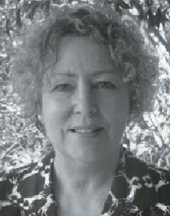
Susan Teerds Kidsafe Queensland

What are my choices for safely transporting adults and children with disabilities and medical conditions in motor
vehicles, motor homes, buses and planes.
This presentation will explore the Road Rules, Australian Standards, the use of specialty harness and modified child car restraints. Off-the-shelf car seats can provide great support for low-tone medical needs and also behavioural issues. Do you need a qualification to modify seats? How do you choose between a harness, a car seat or a wheelchair in a vehicle? What is safer? Who can you ask?

THURSDAY 7 MARCH 2024
11.00am 45 mins 11.00am 45 mins
ROOM 1
ROOM 2

Creating the Path to Successful Prescription: Active Manual Wheelchairs Deconstructed

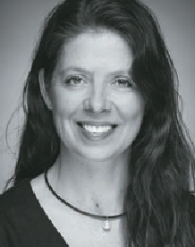
Amy Bjornson Clinical Director - Sunrise Medical

When prescribing active manual wheelchairs, there are multiple factors and measurements which
need to be taken into consideration in order to achieve optimal outcomes. This session will discuss the impact of the wheelchair set up on the user’s propulsion efficiency and the long-term effects of posture and positioning on the body.
We’ll review the evidence on factors that influence propulsion efficiency and long term health and mobility of clients using active wheelchairs full time. Additionally, we will consider various configurations and how they impact a client’s mobility. We’ll provide steps for decision considering a
user’s body, functional skills, environment of use, transportation, and participatory goals.

Empower Equip Include

Discussion lead by April Hobbs

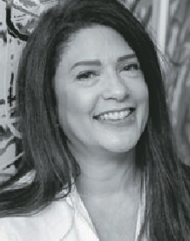
“Exploring the Workforce Gap: Understanding the
Disparity for Young People with Disabilities” aims to address crucial aspects of disability employment.
Moderated by April Hobbs, It features
a distinguished panel of industry professionals who will delve into the challenges and opportunities faced by young people with disabilities in the workforce.
The main focus will be on empowering, equipping, and including these individuals, highlighting the importance of building accessible and successful pathways for their employment and entrepreneurship.
This discussion is expected to shed light on the existing disparities and offer practical solutions to bridge the workforce gap, fostering an inclusive and diverse working environment.

THURSDAY 7 MARCH 2024
11.00am 45 mins
ROOM 3

Pelvic Belts – more than just an afterthought, and definitively not a seatbelt!

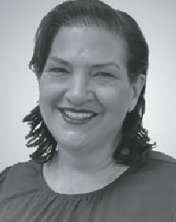
Tracee-lee Maginnity, Permobil Clinical Services Specialist

We often spend considerable time assessing and looking at back supports and cushion solutions to
meet someone’s seating needs.
The final point of control or postural support is often an anterior postural support accessory such as a pelvic positioning belt or harness. How this is positioned is essential to the postural outcome, and if incorrectly mounted can undo all the positioning of the cushion and backrest.
This session will investigate where pelvic belts are fitted and the impact correct (and incorrect) mounting and positioning has on postural and functional control.

THURSDAY 7 MARCH 2024
1.00pm 45 mins 1.00pm 45 mins
ROOM 1
ROOM 2

What do I do with my equipment, how
can we use it?

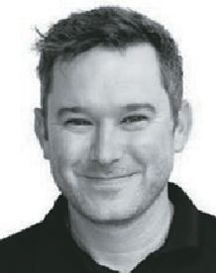
Rob Norman, National Educator RTD

The process of getting AT Equipment for your clients can be overwhelming and
sometimes challenging.
Join us on the journey through Planning, Prescribing and Implementing process of getting equipment into home, therapy and the community to ensure you’re putting the best foot forward for the therapist involved, and enable the client to achieve their goals!

Measuring outcomes: Three keys to success!

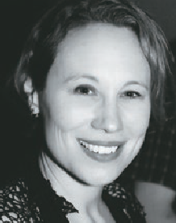
Dr Emma Friesen, Senior Research Fellow, Rehabilitation,
Ageing and Independent Living (RAIL) Research Centre, Monash University
Measuring outcomes
of AT and service provision is important! Three keys to the successful use of outcomes measures are (1) understanding how outcomes measurement instruments are developed, constructed, and psychometrically evaluated, (2) having skills to evaluate and select appropriate instruments using published psychometric, administrative, and procedural data, and
(3) understanding the practical realities of implementing and administering
outcomes measures in “real world” service delivery settings.
This session will include tips and strategies for locating and accessing published information from peer-reviewed and
grey literature, outcomes measurement databases, and administration manuals – even without full access to academic or research repositories.

THURSDAY 7 MARCH 2024
1.00pm 45 mins
ROOM 3

Finding Balance: Creating Functional Stability for Wheelchair Users

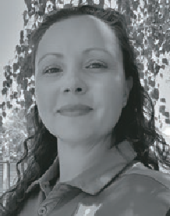
Lauren Kerr, Director of Clinical Services,
Linds Rehabilitation Equipment

Take it from an experienced wheelchair seating clinician, the
hardest wheelchair users to provide postural supports for are the ones who move! Any therapist prescribing wheelchairs will confidently tell you that we must start at the pelvis! But do we truly understand what it means to create a stable base support? What happens to the base of support when the wheelchair user moves
in and out of positions to function? What components on the wheelchair frame and seating system can we use to enhance participation for the individual?
This session will take you on a journey through the assessment process to make our client centered outcomes match the features we prescribe in available product.

THURSDAY 7 MARCH 2024
2.00pm 30 mins 2.00pm 30 mins
ROOM 1
ROOM 2

Setting up for success with new powered mobility users

Prithy Sivaraman, Physiotherapist, Clinical Hub - Sunrise Medical

You’ve had a successful trial with your client and they’ve demonstrated the ability to safely negotiate and traverse their environment and/ or the capacity to do so
with coaching. When their new power chair is ready for delivery, we’ll look at to set them up for success.
From those who are worried about not being tech savvy to client’s who have had powered seating functions added. Based on individual needs and skills we’ll look at solutions for different users and identify how to make driving and operation as straight forward as possible.

Early interventions with custom-moulded seating

David Fagan - Managing Director, Paragon Mobility

Historically, custom moulded seating has been a last resort to preserve an individual’s ability to sit. Recent advances in custom moulded seating, based
on orthotic and prosthetic principles, have incorporated lighter, breathable and less bulky materials into manufacturing. This has significantly expanded potential for custom seating as an option for early intervention.
In this session, we’ll discuss custom shaped seats and back supports, correct orientation of seating for a constructive relationship with gravity, and the importance of optimal wheelchair configuration and seating interface to maximize mobility, function, and skin care. We’ll also review strategies for client assessment, simulation, fitting, and documentation.

THURSDAY 7 MARCH 2024
2.00pm 30 mins
ROOM 3

Let’s face it together!
The 5 most common mistakes made during wheelchair seating evaluations

Edward Milner, Clinical Educator- Medifab

In clinical practice, applying clinical reasoning may appear straightforward, yet
it’s laden with challenges and potential pitfalls. Even highly experienced therapists can inadvertently compromise outcomes through overlooked steps, leading to future complications. Wheelchair seating evaluations pose intricate challenges as therapists navigate diverse client needs, preferences, and constraints. While time
and environmental pressures can contribute, unintentional mistakes persist and adversely affect clients.
This session aims to shed light on 5 commonly neglected aspects of wheelchair seating assessments, fostering clinical awareness and driving positive change.
Through reflection and practical examples, we seek to enhance clinical practice.

