CANBERRA
8-9 NOVEMBER 2023
EXHIBITION PARK (EPIC)
Northbourne Ave, Mitchell

SEMINAR PROGRAM

OPENING HOURS
Wednesday 8 November 8:30am – 4:30pm
Thursday 9 November 8:30am – 3:00pm

events@atsa.org.au www.atsaindependentlivingexpo.com.au

Organised by Media Partners

WEDNESDAY 8 NOVEMBER 2023
8.15am 45 mins
Breakfast Session

The future of OT and AT:
Should OTs be embracing technology or shying away from it?

A panel discussion facilitated by Occupational Therapy Australia. Light breakfast provided. Limited numbers.

ROOM 1
ROOM 2
9.00am 45 mins 9.00am 45 mins

NDIS Presenter
Dr Lloyd Walker
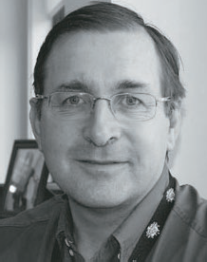

Managing behaviours of concern through wheelchair interventions that allow for sensory expression and enhance participation.

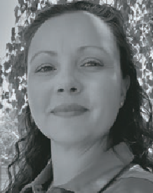
Lauren Hunter, Director of Clinical Services, Linds Rehabilitation Equipment

We all have ways in which we communicate and express ourselves. At times, individuals with disabilities are labelled as having “behaviours of
concern” because their communication, sensory and functional needs are not being met. Often these individuals are also wheelchair users who become reliant on their wheelchairs not only for mobility, but for enhanced participation and socialisation through meaningful ADLs. What happens when certain features prescribed with good intention, are used in ways that promote restrictive practices? Are there features of wheelchairs, that when appropriately prescribed, reduce agitation to enhance sensory and motor experiences for those users who have been labelled “destructive” and “difficult”. Together, we can unravel the assessment process essential to understanding the individual in
the wheelchair. We will discover intervention practices to consider, that will lead to a deeper understanding of how the features you prescribe in a wheelchair can help the goals you set to improve the quality of life for this population demographic.

2 Register at www.atsaindependentlivingexpo.com.au
Correct as at 18 October 2023

WEDNESDAY 8 NOVEMBER 2023
9.15am 30 mins
ROOM 3

Empowering Mobility:
a comprehensive guide to choosing the right power assist device

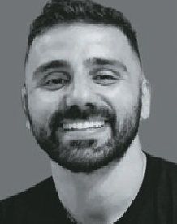
Justin Boulos, Occupational Therapist /
Assistive Technology Professional

This presentation will provide an overview of power assist devices for manual wheelchairs.
There will be discussion on how power assists can improve independence, increase mobility, and enhance overall quality of life for people with mobility impairments.
We will explore the four different types of power assists, including rear mounted, push rim activated, joystick operated, and front mounted devices.
Attendees will learn about the unique features, benefits, and limitations of each type of power assist, and gain insights into the specific use cases where each type is most effective.

Register at www.atsaindependentlivingexpo.com.au 3
Correct as at 18 October 2023

WEDNESDAY 8 NOVEMBER 2023
10.15am 45 mins 10.15am 45 mins
ROOM 1
ROOM 2

To Get Around On Any Ground: What’s the methodology when scripting assistive technology?

Roseanna Tegel - Permobil APAC

Are you new to working with complex assistive technology? Ever wondered if there is a simple way to decide
if the client would be more functional in a manual or powered wheelchair? Want to learn what different equipment is out there and what assessments we can use to assist in the decision-making process?
This workshop will run through the clinical reasoning process when deciding what mobility device and seating system will maximise the clients’ independence.
In this session we will
- Gain an understanding of what assessments we can use to choose a seating system and mobility base.
- Identify the 3 main PWC drive wheel configurations.
- Identify the different MWC frames and understand why you may pick one frame over another.

Vehicle Transport for Children

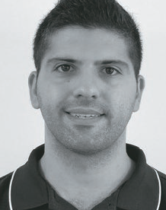
Amin Akbarian - CEO, Mobility Engineering and Jamie Cockle -
Clinical Educator, Medifab
Planning for a child’s transport needs can be challenging due to the rapidly changing heights, weights, and function throughout their life.
This session will run through the vehicle transport considerations for children. Starting with an outline of a transport plan, we will
identify the areas of focus required through age groups from 0 to 16.
Once a transport plan has been identified we will then focus on solution considerations within the following areas of vehicle transport: Car Seats, Vehicle
seat positioning, Transfers and Wheelchair access.

1 Register at www.atsaindependentlivingexpo.com.au
Correct as at 18 October 2023

WEDNESDAY 8 NOVEMBER 2023
10.15am 45 mins
ROOM 3

Unlocking Autism Resources: A Conversation with Industry Leaders

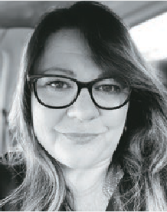
Anita Aherne, Living on the
Spectrum and David Tonge, Amaze

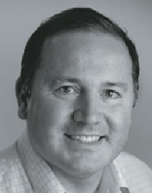
Join us for a discussion with industry leaders, Anita Aherne, the visionary behind Living on the Spectrum, and David Tonge, AMAZE’s Chief Operating Officer.
Uncover the keys to accessing vital autism resources and deepening your understanding
of supporting autistic individuals.
Explore the initiatives undertaken by their organisations to improve information and resource accessibility. A chance to engage, inquire, and empower yourself with valuable skills to access and support for autistic individuals. An opportunity to broaden your knowledge and make a difference.

Register at www.atsaindependentlivingexpo.com.au 2
Correct as at 18 October 2023

WEDNESDAY 8 NOVEMBER 2023
11.15am 45 mins 11.15am 45 mins
ROOM 1
ROOM 2

Overcoming Pain Barriers: Maximising Participation and Achieving Lifestyle Goals for Wheelchair Users

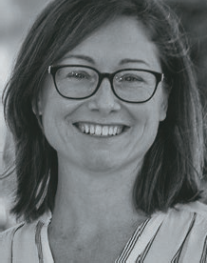
Kate Pain - Clinical Educator (OT), GTK and Romi Russek - Assistive Technology Consultant (OT), GTK
What limits people with disability in their ability to achieve their goals and live the life they want to live?
Chronic pain is a common experience for individuals living with disability and can be overlooked when prescribing and assessing
assistive technology needs. Understanding our client’s experience is important when working with them to achieve their assistive

Paediatric Panel

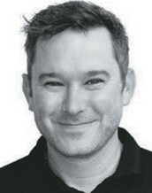
MODERATOR: Robert Norman – National Educator, RTD

This fully interactive session answering your questions and challenges in big world of Paediatrics, join the panel with over 50 years of experience working with the Paediatric population

PANELISTS:

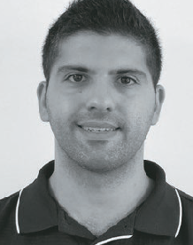

technology and lifestyle goals.
This presentation will explore how pain can limit functional mobility, affect emotional wellbeing and lead to social isolation.
We will discuss common causes of pain and how they relate to aspects of the seated position in a mobility device to either enhance or reduce function. We will also advocate for pain to be included as a domain in assessment for assistive
technology, and for specific goals to be set to maximise participation, while considering pain as an inhibiting factor.
Amin Akbarian – CEO Mobility Engineering
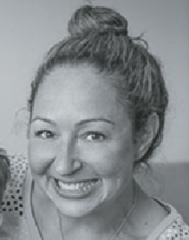
Ali Gebhardt - Clinical Director NAPA
Jamie Cockle – Medifab Clinical Educator

3 Register at www.atsaindependentlivingexpo.com.au
Correct as at 18 October 2023

WEDNESDAY 8 NOVEMBER 2023
CANBERRA 8-9 NOVEMBER 2023
Seminar Program
1.00pm 30 mins 1.00pm 30 mins
ROOM 1
ROOM 2

Considerations for the Bariatric Client

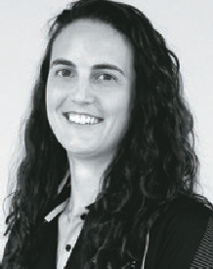
Silvia Gonzalez - Product Specialist, Occupational Therapist & Bianca Brady - Clinical Educator, Occupational Therapist,
Astris PME

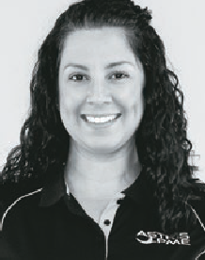
Anthropometrics and weight are often the biggest influence when selecting equipment for a bariatric client.
However, there is more to take into account when assessing for and
prescribing assistive technology for this population. We need to understand the person’s goals, their function, their needs and wants regarding daily activities. As well as their anthropometrics, weight distribution, skin integrity, transfers, manual handling and support worker needs.
Bianca and Silvia will provide insight and advice on how to undertake an assessment, including discussing common postures
and how to best support these to promote function. We will also discuss considerations for managing skin integrity as well as touching on how suitable Assistive Technology can help reduce manual handling concerns. And most importantly what we can do as Therapists through
use of suitable equipment to enhance independence.

Ages and stages – positioning throughout the day in the real world

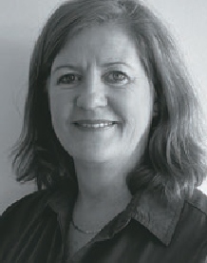
Jacinta Maurin - Postural Care and Paediatric Unit Manager, Sunrise Medical
What Assistive technology do you need when?
Tracing the path from being newly diagnosed onward this session will help you identify what seating and mobility solutions can help maximise independence and function. With a Paediatric focus we will consider how best to integrate AT to assist with engaging children throughout the day.
Come find out what questions to ask and how best to determine supports needed moving through childcare, kindy and upward.
Identify different positioning options that work over a range of environments and how to successfully prescribe them.

4 Register at www.atsaindependentlivingexpo.com.au
Correct as at 18 October 2023

WEDNESDAY 8 NOVEMBER 2023
CANBERRA 8-9 NOVEMBER 2023
Seminar Program
1.00pm 30 mins
ROOM 3

Driving advancements in safe and accessible transport for children with disabilities

Helen Lindner, MACA

Register at www.atsaindependentlivingexpo.com.au 5
Correct as at 18 October 2023

WEDNESDAY 8 NOVEMBER 2023
CANBERRA 8-9 NOVEMBER 2023
Seminar Program
1.45pm 45 mins 1.45pm 45 mins
ROOM 1
ROOM 2

Successful Manual Wheelchair Delivery! You’ve chosen the frame (and the colour ...)
but Don’t Stop There!!! Configuration to maximise long
term comfort and success

Amy Bjornson - Clinical Director, Sunrise Medical

What does CONFIGURATION even mean? Learn how to adjust and configure manual wheelchairs to maximize independence, function and long-term mobility with avoidance of overuse injuries and discomfort.
We’ll discuss frame selection, configuration to promote safe, functional independence in an active manual wheelchair. We’ll investigate how different frame styles and set-ups affect propulsion, comfort and ultimately client function.
Come Ready for Action- this workshop is jam-packed with immediately applicable learning opportunities.

Take a seat: Customising off the shelf wheelchairs and cushions

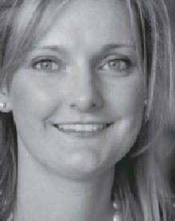
Elissa Coates - National Clinical Education Manager, Novis Healthcare

With so many options available, choosing the right product for the right person is
imperative. Understanding cost effective ways of accommodating the individual needs of your client will assist with stability, comfort, function and minimise risks of immobility.
Utilising clinical evidence and best practice we will establish how to ensure individual needs and goals are met utilising readily available product ranges.
In this session we will look at:
- Goals of seating
- Key features of off the shelf seating products
- Options for individualised cushion implementation
- Customisation of financially achievable solutions

Register at www.atsaindependentlivingexpo.com.au 6
Correct as at 18 October 2023

WEDNESDAY 8 NOVEMBER 2023
CANBERRA 8-9 NOVEMBER 2023
Seminar Program
1.45pm 45 mins
ROOM 3

Power functions that create unique client centered solutionS

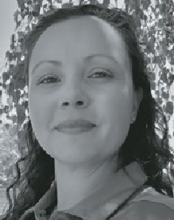
Lauren Hunter, Director of Clinical Services, Linds Rehabilitation Equipment

Often the difference between disability and ability is application
of assistive technology that matches the unique functional abilities of our clients.
There have been many advances in technology for how individuals who use powered mobility can add on specialized seating functions and controls to enhance their participation in the world that surrounds them.
Join us to explore the clinical applications of powered lateral tilt, latitude (seat to floor), anterior tilt and standing functions; along with alternate drive control systems, that through clinical application, have vastly improved the quality of life for the unique individuals we will showcase through our clinical studies.
We will explore the research available to assist in our decision making and ensure we use outcome measures that showcase client centered processes aren’t lost in a tick box society.

- Register at www.atsaindependentlivingexpo.com.au
Correct as at 18 October 2023

WEDNESDAY 8 NOVEMBER 2023
CANBERRA 8-9 NOVEMBER 2023
Seminar Program
3.15pm 45 mins 3.15pm 45 mins
ROOM 1
ROOM 2

Improving AT Outcomes by strengthening the collaboration of the AT Supplier and Therapist

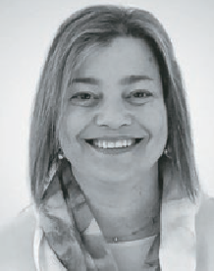
Lois Brown - National Clinical Education Manager, ILS

Working relationships are formed when developing Assistive
Technology solutions for people with disabilities. This session will delve into the relationship formed by AT suppliers and prescribing therapists. It will explore the roles of each party, the strategies to improve communication between each other and how this working relationship
can get the best AT solutions for our clients.
We will be presenting some case studies, examples of templated documents therapists can use and discuss how to approach scripting when there is inequity with experience.
This session will benefit new therapists and AT suppliers entering the Assistive Technology space.

A proactive approach to facilitate and maintain occupational engagement with a power assist device.

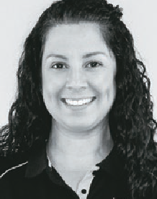
Bianca Brady - Clinical Education Co-Ordinator, Astris PME

Promoting occupational engagement for a manual wheelchair user
is a key goal for introducing a power assist device. It is a goal that aims to optimise and sustain independence with wheeled mobility and life roles while reducing the risk of injury to the user.
Despite setting up for optimal self- propelling efficiency; increased time, distance, and difficulty of terrain, increases the risk of injury and physical demands
on the individual. The outcome of this has significant potential to compromises level of function in all areas of daily life.
Understanding considerations and features of power assist devices and when to introduce them, will serve to build confidence in identifying a device that can achieve targeted goals and ultimately facilitate and maintain occupational engagement.

- Register at www.atsaindependentlivingexpo.com.au
Correct as at 18 October 2023

WEDNESDAY 8 NOVEMBER 2023
CANBERRA 8-9 NOVEMBER 2023
Seminar Program
3.15pm 45 mins
ROOM 3

Wheels Up - Travelling with a wheelchair

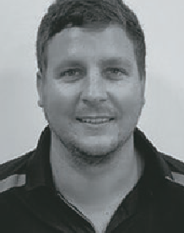
Mitchell Stone, wheelchair user

This session will explore the trials and tribulations that wheelchair users face when travelling and explore the different ways that these can
be overcome.
We will explore travelling with manual and power wheelchairs, how to minimize damage to equipment, what you can
do to make your transit more comfortable and how to make the whole experience less stressful.
There will be tips on how to prepare for your journey and what to expect when you get to the airport.

Register at www.atsaindependentlivingexpo.com.au 9
Correct as at 18 October 2023

THURSDAY 9 NOVEMBER 2023
CANBERRA 8-9 NOVEMBER 2023
Seminar Program
8.00am 45 mins
ROOM 1

Navigating Autism, Self-Harm, and Problematic Behaviour

Anita Aherne, Living on the Spectrum and Joanne Seymon,
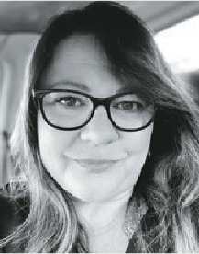
Kaiko Fidgets

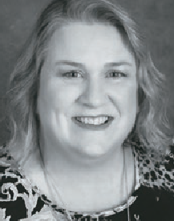
This hands-on workshop provides a unique opportunity to gain a lived experience perspective and understand the Autistic thought process in relation to self-harming behaviors. We also explore the concept that not all self-intended pain or pressure should be prevented.
Join our immersive workshop led by Anita Aherne, Founder of Living on the Spectrum, the National Autism Directory, and
Joanne Seymon, an Occupational
Therapist and founder of Kaiko Fidgets. Both facilitators are neurodivergent themselves and parents of autistic children.
Through interactive experiences with sensory aids, participants will deepen their understanding of their applications and develop positive coping strategies for neurodivergent individuals and their parents. This workshop focuses on preventing and understanding self-harm behaviors related to sensory issues.
Join us for this informative workshop and gain practical knowledge that will empower you
to positively impact the lives of autistic and neurodivergent individuals. Don’t miss out on this immersive and tactile learning experience.
This workshop is for Allied health, healthcare professionals, parents, carers, neurodivergent and Autistic individuals, and anyone wishing to learn more about Sensory Self-harm behaviours.

Register at www.atsaindependentlivingexpo.com.au 10
Correct as at 18 October 2023

THURSDAY 9 NOVEMBER 2023
CANBERRA 8-9 NOVEMBER 2023
Seminar Program
9.00am 45 mins 9.00am 45 mins
ROOM 1
ROOM 2

What Are My Options - Clinical Reasoning Power Add- On and Power Assist Products

Amy Bjornson - Clinical Director, Sunrise Medical

Power assist and power add on systems have rapidly evolved in recent years. They are
commonly considered as
an alternative to a power wheelchair or as a method of making a manual wheelchair a more functional option. This workshop will focus on clinical implications and decision process for each category. We’ll look the indications for these technologies and objective measures useful to qualify the technology for your client. We’ll also
discuss education and training strategies to maximise functional gains.
Following this presentation, participants will understand the different types of power add on/ assist systems that can be added to manual wheelchairs: their efficacy and considerations for usage to match client criteria/goals using objective measures to qualify their decision.

Reaching New Heights:
How Power Seat Elevation can Maximise Participation and Independence

Kate Pain - Clinical Education (OT) and Romi Russek-
Assistive Technology Consultant (OT), GTK
Have you had a recent rejection from the NDIS of power seat elevation (vertical lift) on the grounds that it doesn’t meet the ‘reasonable and necessary’ criteria? We hear you!
This presentation will focus on the role of power
seat elevation (vertical lift) and unpack how this function can be used to maximise participation for power wheelchair users. Through case studies and evidence from the literature, we will demonstrate how power seat elevation enables clients to
achieve their goals as a stand-alone feature, or in combination with other power seat functions.
We will highlight the importance of considering an individual’s physical and functional abilities, as well as their
environmental and lifestyle factors when determining which power seat functions are best suited for them.

- Register at www.atsaindependentlivingexpo.com.au
Correct as at 18 October 2023

THURSDAY 9 NOVEMBER 2023
10.00am 30 mins 10.00am 30 mins
ROOM 1
ROOM 2

Regulation Basics for Assistive Technology

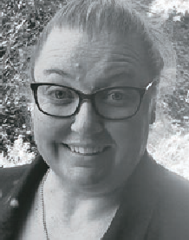
Rebecca Bateson, Therapeutic Goods Administration (TGA)

An overview of when assistive technology products are regulated by the Therapeutic Goods Administration, insight into recent
regulatory changes and a summary
of reform work currently underway that may impact the sector.

TD Pilot: Eye control for the iPad

Loren Apokourastos -
Assistive Technology Consultant, Link Assistive

This session will introduce the new made for iPad (MFI) TD Pilot, which is an eye-controlled
communication device for iPad. It has been
designed to empower people with physical impairments such as MND, spinal cord injury or cerebral palsy to communicate and use their favourite apps using their eyes and other access methods.
We will demonstrate the TD Pilot which has been made for Apple’s iPadOS accessibility features and enables tasks such as tapping or scrolling using your eyes, fingers or a switch. Eye gaze users can enjoy all the content available on an iPad, including social media, games, entertainment, educational apps and more.

- Register at www.atsaindependentlivingexpo.com.au
Correct as at 18 October 2023

THURSDAY 9 NOVEMBER 2023
11.00am 45 mins 11.00am 45 mins
ROOM 1
ROOM 2

Getting out and About – The Importance of Teaching Wheelchair Skills

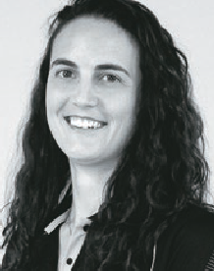
Silvia Gonzalez - Product Specialist, Occupational Therapist, Astris PME & Patrick Will - OT Student and
Long-term Wheelchair User
We all have to be taught new skills. Take
learning to ride a bike for example, without being shown or provided any training on how to ride the bike we aren’t able to use it to its full potential.
We may be able to jump onto the bike, roll forward with our feet on the ground, but until we are provided with the opportunity to practice using the pedals and finding our balance we are limited in where we can go.
The same is true for learning how to use a wheelchair. Without training and practice we might be able to figure out the basics of moving forward. However, to become proficient we need to be taught.
This session will explore the evidence behind the importance of teaching wheelchair skills and delve into practical tips on how to facilitate this training with your clients to enhance outcomes.

An OT’s Field Guide to working in the NDIS

Sarah Collison - Director, Verve OT

Navigating and understanding the NDIS, it’s systems and processes can be
stressful, confusing and send many therapists into a tailspin on the best of days!
This session will guide OT’s through the common OT services, pitfalls to avoid and strategies for survival. As our profession adjusts to the ever-changing disability landscape and challenges of workforce shortages, this session will empower OTs to embrace their role within the NDIS scheme for the longer term.

Register at www.atsaindependentlivingexpo.com.au 13
Correct as at 18 October 2023

THURSDAY 9 NOVEMBER 2023
1.00pm 45 mins 1.00pm 45 mins
ROOM 1
ROOM 2

What do I do
with my equipment now I have it?

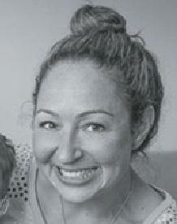
Ali Gebhardt - Clinical Director NAPA
Robert Norman - National Educator, RTD

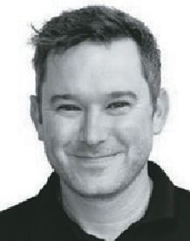
The process of getting AT Equipment for your clients can be overwhelming and
sometimes challenging.
Join us on the journey through Planning, Prescribing and Implementing process of
getting equipment into home, therapy and the community to ensure you’re putting the best foot forward for the therapist involved, and enable the client to achieve their goals!

The only way is up:
The possibilities of Ceiling Lifter design and function

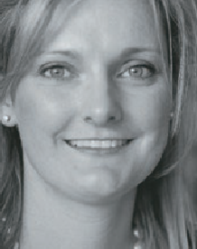
Elissa Coates - National Clinical Education Manager, Novis Health

With evidence and experience, the benefits of lifting people using ceiling based lifters is
overwhelmingly positive. Understanding Ceiling Lifters will allow you to accurately plan for the most effective solutions when solving the complexities of patient handling.
Using evidence based practice this session will ensure you have the most up to date and comprehensive information needed for Assistive Technology prescription.
In this session we will cover:
- Benefits and practicalities of patient handling with ceiling lifters
- Components of a ceiling track system
- Design types and benefits of varied set ups
- Costs and Return on Investment
- Functional and Rehabilitation possibilities

14 Register at www.atsaindependentlivingexpo.com.au
Correct as at 18 October 2023

THURSDAY 9 NOVEMBER 2023
2.00pm 30 mins
ROOM 1
ROOM 2

When manual is
no longer enough – PAD Considerations

Roseanna Tegel - Permobil APAC

This session will look at the development of powered assistive
technology devices that can be added to manual wheelchairs. This area of AT encompasses a range
of very different devices, how they attach, how they function, how the user accesses the drive and the impact on the manual chair are some of the points we will discuss.
We will take a look at the available evidence including a recent survey of end users
that highlights the variability of device choices. From amplification of push stroke to converting a manual chair to a powered trike, we will look at some of the advantages and disadvantages of each.

Risk assessment: prescribing an appropriate alternating surface

Jemma Cooke - Occupational Therapist, Pegasus Healthcare

Pressure injuries present a significant impact
on the individual with economical costs seen
across all healthcare settings. Occupational therapists are often called upon to assess and provide appropriate recommendations when an individual presents with a pressure injury. Being equipped with the right skills and knowledge to assess the risk and relieve pressure are fundamental in prescribing an alternating surface.
Following this presentation, therapists will have a better understanding of how to identify when an individual is at risk of developing a pressure injury and the appropriate steps required in order to provide better outcomes.

Register at www.atsaindependentlivingexpo.com.au 15
Correct as at 18 October 2023

