PERTH
31 MAY - 1 JUNE 2023
CLAREMONT SHOWGROUND
1 Graylands Rd, Claremont WA

SEMINAR PROGRAM

OPENING HOURS
Wednesday 31 May 8:30am – 4:30pm
Thursday 1 June 8:30am – 3:00pm

events@atsa.org.au www.atsaindependentlivingexpo.com.au

Principal Supporter

Organised by Media Partners

WEDNESDAY 31 MAY 2023
9.15am 45 mins

Breakfast Session

8.15-9.00am
Hosted by Occupational Therapy Australia
Light breakfast provided Limited numbers

9.15am 45 mins
ROOM 1

NDIS SESSION
Virtual Presentation
Dr Lloyd Walker – Director, Assistive Technology Markets, Provider & Market Development Division,
National Disability Insurance Agency

ROOM 2

Optimising a wheelchair: using the technology to ensure ongoing success
Tom Whelan, Vice President Product
Development at Ki Mobility

Professionals involved in manual wheelchair prescription must work with end-users to create
a configuration that achieves optimum results for comfort, postural stability, function, and propulsion efficiency.
This presentation will dive into the details of wheelchair set-up factors that must be considered to optimise postural stability and propulsion efficiency for end users.
Factors include horizontal axle position, vertical axle position, and others. The relationship between these factors and the current research supporting optimisation of each factor will be discussed. We will
address making prescriptive decisions while providing for potential changes in clinical need and the value of implementing follow- up to reoptimise the wheelchair over time.

WEDNESDAY 31 MAY 2023
10.30am 30 mins

ROOM 1
ROOM 2

AT Chat and Assistive Technology Mentoring service
Kristy Harper, Innovation and Growth Manager iLA

AT Chat is a peer-led, co-designed community for assistive technology (AT) users to share information and lived experiences about AT.
The program’s aim
is to deliver a peer-led information and mentoring service that provides their community with the opportunity to build their AT decision-making capability and share their expertise with each other and the broader community.
Through an ongoing process of co-design, an online portal and peer mentoring program have been developed.
Following a Peer Mentoring pilot program in 2020, AT Chat launched an AT Mentoring service in November 2022.
Case studies shared will show how
peer-based AT Mentoring has supported people to make decisions about their assistive technology to enable them to ‘Live Play Work.’

Toileting and special needs: where to start?
Lori Potts, Physical Therapist,
Rifton Product and Training Specialist

For many parents and teachers of children with special needs, toilet training can seem like an unattainable goal.
Each child has unique health issues, physical disabilities, emotional/
behavioral challenges, cognitive and learning disabilities as well as communication barriers.
Nevertheless, an individualized, consistent toileting routine can have a significant and positive impact on quality of life, with improved continence and toilet training success outcomes.
How to begin? This session equips the clinician with evidence-based information and resources with which to move forward and support families and schools to address this central issue.

WEDNESDAY 31 MAY 2023
11.30am 30 mins

ROOM 1
ROOM 2

Parenthood with vision loss
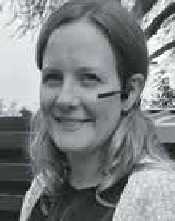
Sinead Bryant, Occupational Therapist, Visibility and Emmanuel Lee,
Senior Officer for Assistive
Technology, Visibility

Being a parent, something so many of us dream of becoming, yet something so many of us know so little about until we are in the thick of it.
For Sinead, a mum to toddlers, and Emmanuel, a dad to teens, their significant vision impairments meant
that parenthood definitely through a few additional challenges their way.
From navigating newborn feeds, reading bedtime books and ensuring safe walks to the park. To managing school drop- offs, helping with homework, and guiding your teen on social media. Here how
practical, thoughtful strategies and assistive technology solutions assisted them through parenthood.

Managing behaviours of concern through wheelchair interventions that allow
for sensory expression and enhance participation
Lauren Hunter, Director of Clinical Services, Linds Rehabilitation Equipment

We all have ways in which we communicate and express ourselves. At times, individuals with disabilities are labelled as having “behaviours of concern” because their communication, sensory and functional needs are not being met. Often these individuals are also wheelchair users
who become reliant on their wheelchairs not only for mobility, but for enhanced participation and socialisation through meaningful ADLs. What happens when certain features prescribed with good intention, are used in ways that promote restrictive practices? Are there features of wheelchairs, that when appropriately prescribed, reduce agitation to enhance sensory and motor experiences for those
users who have been labelled “destructive” and “difficult”. Together, we can unravel the assessment process essential to understanding the individual in the wheelchair. We will discover intervention practices to consider, that will lead to a deeper understanding of how the features you prescribe in a wheelchair can help the goals you set to improve the quality of life for this population demographic.

WEDNESDAY 31 MAY 2023
1.00pm 45 mins

ROOM 1
ROOM 2

Paediatric Panel

MODERATOR:
Robert Norman – RTD National Educator

PANELISTS:
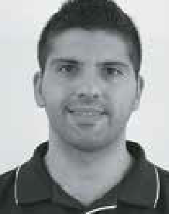
Amin Akbarian – CEO Mobility Engineering
Ashleigh Germain – Director Little Bodies Therapy

Jamie Cockle – Medifab Clinical Educator
Dr Noula Gibson - Research
Co-ordinator/ Physiotherapist
at Perth Children’s Hospital

Levelling Up
Lauren Farrell,
Occupational Therapist, Indigo

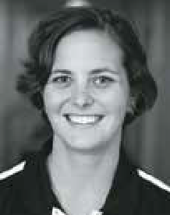
Facilitating inclusive game play through use of alternative access
If you’re a complete ‘noob’ into the area of personal gaming accounts, this is the presentation for you.
Indigo therapist Lauren Farrell will guide you through some alternative access options for games and outline the set up process to connect to popular gaming platforms.
A must for anyone interested in exploring personalised gaming environments to facilitate inclusive game play with a
view to building online connections and community participation for clients.

WEDNESDAY 31 MAY 2023
2.15pm 30 mins

ROOM 1
ROOM 2

Ride a bike or take a hike
Andrea Espei, head of training at Schuchmann Reha / Germany

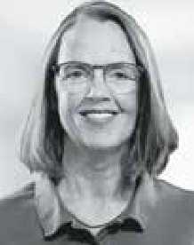
No human life is thinkable without movement: what about children with physical impairment?
Goal orientated therapy tends to enable them to decide independently
where they want to do what they want to do. Traditional gait training is somehow limited – this is why we would like to focus on ideas which opens the spectrum und introduce bike (trike) riding as a therapy medium. Discussing some case studies, we will build up some knowledge about gait pattern and suitable walking aids, about muscle hyper- and hypoactivity an gait phases and the influence of bike (trike) riding and bike fitting used as media for therapy.
After this session you will have:
- Knowledge about muscle activity in the pedalling circle.
- Ideas of using special bike fitting to strengthen muscles .
- Possibilities to broaden your gait training with more fun and orientated to daily activities.

Bums, Bowels, and Bladder: Plane Travel and Things to Consider for Wheelchair Users
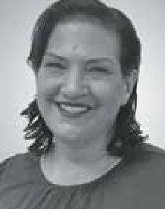
Tracee-lee Maginnity, Clinical Services Specialist -
Permobil APAC

What main things do wheelchair users need to consider prior to plane travel and what supports
are out there to assist? How do we make sure pressure care needs are met on long- haul flights and how can wheelchair users safely complete their bladder and bowel care 30,000 feet high?
This presentation will review current EBP with reference to best practice guidelines for pressure care and bladder and bowel management and dive into practical solutions to ensure this can be completed on a plane.

WEDNESDAY 31 MAY 2023
3.15pm 45 mins

ROOM 1
ROOM 2

Supporting children safely for travel, addressing postural support needs in available special purpose car restraints
Jamie Cockle, Clinical Educator, Medifab

Car travel can be exciting, providing us with a sense of
freedom and access to
our community and beyond! For children with disabilities and their families however, the right piece of equipment can be the difference between safe and unsafe access to vehicle transportation. Whether its inner city driving for visits to therapy centres,
or long commutes from regional areas for specialist assessment or intervention,
children with disabilities can spend a long time in a vehicle.
For those with limited postural control, travel can be stressful and dangerous without the right support. Whilst “off the shelf” car seats provide some support for occupants, for children with less postural control this may be insufficient.
This presentation will outline the challenges associated with poor postural control particularly as it relates to travel. We will discuss the pro’s and con’s of different options available in the market to support children and discuss the clinical applications for assessment and intervention.

Assistive technology for the bariatric client – what are you forgetting to consider?
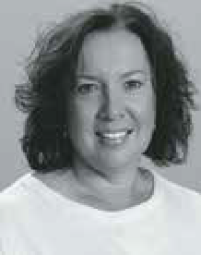
Annette Terranova, Clinical Educator and Trainer,
Unicare Health

Obesity has become a major medical issue affecting society today. One of the key
challenges with obesity is the increased effort required for mobility and general lifestyle independence.
Obese clients frequently face complex barriers limiting their participation in meaningful occupations. As the obese population grows, the needs of larger people and those who care for them must be addressed.
This session looks at prescribing Assistive Technology Solutions that matches a client’s plus-sized body type to facilitate function, safety and quality of life.
Looking beyond safe working load, this session will look at the client’s
anthropometric details, functional reach, pressure care and other often neglected considerations for the appropriate selection of assistive technology such
as bariatric beds, mattresses, cushions, manual handling, and mobility equipment.

THURSDAY 1 JUNE 2023
8.30am 1 hr, 30 mins 9.15am 45 mins

ROOM 1
ROOM 2

BREAKFAST SESSION 830-10:00am
Mat Evaluation 101 for Wheelchairs
Skills training – tips, tricks and advice from what I have learned along the way
Amy Bjornson,
Clinical Director, Sunrise Medical

This workshop is for therapists involved in seating and wheelchair assessment.
In this session, we will demonstrate the client assessments - both supine and sitting. We’ll provide practical tips and tricks to make you much more comfortable doing
a MAT assessment. You will learn how to perform the skills on a variety of client types. We will consider which steps can be skipped for less complex clients, what is critical for complex cases and how to alter the process to work for your bariatric clients.
This course will facilitate:
- Hands on skills training for MAT assessment - with insight and advice garnered from years of practice
- Translation of the assessment findings into practical trial equipment selection
- Achieving positive clinical objective outcomes

Use and useability of personal alarms
Linda Tran, Principal Consultant - Clinical Excellence Indigo

The prescription of personal alarm systems has been a popular option to increase older adults’ sense of security in their homes and the community, in facilitating contact with others in
the event of an emergency such as falls.
Despite increasing a sense of security, anecdotal evidence indicates that not all older people who were prescribed these items used the technology in the case of an emergency.
As a provider, Indigo has been gathering information around the most effective methods for prescription and use of personal alarms to benefit clients and ensure funding expenditure best meets clients’ needs. In 2020 Indigo commissioned research with Curtin University to establish actual perceptions and practices of personal alarm users.
The research explored factors influencing the successful uptake and sustained use of personal alarms and revealed that whilst the majority of participants believed the idea of having an alarm was beneficial, not all were convinced it was right for them.
This presentation will summarise research findings and recommendations and discuss implications in a clinical and prescription context.

THURSDAY 1 JUNE 2023
10.15am 30 mins

ROOM 1
ROOM 2

TGA
Amanda Craig,
Director – Devices Post Market Reforms & Reviews Section

TD Pilot: eye control for the iPad
Amy Litton, Link Assistive

This presentation will introduce the new made for iPad (MFI) TD Pilot, which is an eye-controlled
communication device for iPad. It has been designed to empower people with physical
impairments such as MND, spinal cord injury or cerebral palsy to communicate and use their favourite apps using their eyes and other access methods.
We will demonstrate the TD Pilot which has been made for Apple’s iPadOS accessibility features and enables tasks such as tapping or scrolling using your eyes, fingers or a switch. Eye gaze users can enjoy all the content available on an iPad, including social media, games, entertainment, educational apps and more.

THURSDAY 1 JUNE 2023
11.00am 45 mins

ROOM 1
ROOM 2

Why we should all be talking about the shoulder
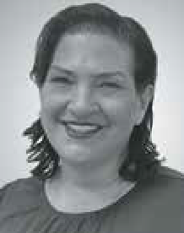
Tracee-lee Maginnity, Clinical Services Specialist - Permobil APAC

How often do we use our shoulders?
What happens if we have shoulder pain or dysfunction? Can we still use our shoulder to complete all the
same activities? Do we understand what is happening from an anatomical level?
Manual wheelchair users are dependent on their upper limbs for propelling a chair, with their shoulders being vulnerable to injury.
This session will focus on understanding the shoulder complex anatomy, physiology and common causes of dysfunction. We will then look at the evidence-based
considerations with wheelchair prescription, to assist end users to maximise their function in the long term.

Postural Care:
The rise of therapeutic positioning in the lying posture around the world
Anna Goldsmith, Director, Simple Stuff Works Associates Ltd and Joana Santiago, Head of Clinical Education
at Medifab

This seminar will look at the development of Postural Care provision from its infancy in the
UK in the 1970s through to the global recognition it is now receiving. The seminar will discuss how
research into the biomechanics of body shape distortion has developed over the last 45 years and how therapists are using this to develop best practice in this field to protect body shape of those people they support. We will debunk some of the myths and misconceptions that are surfacing around this topic and share best practice examples from the UK.

THURSDAY 1 JUNE 2023
12.15pm 30 mins

SPECIAL EVENT
12:15 -12:45
Adaptive Clothing Fashion Show
(near registration desk - all welcome to attend)

Below images are from our first Adaptive Clothing Fashion Show ATSA Independant Living Expo, Brisbane, May 2022

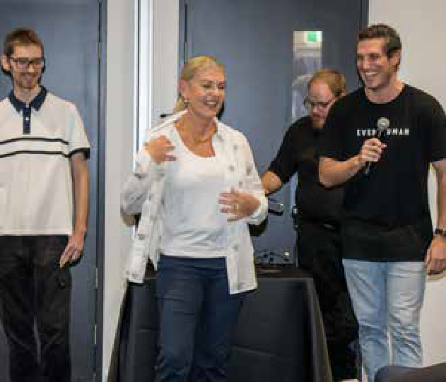
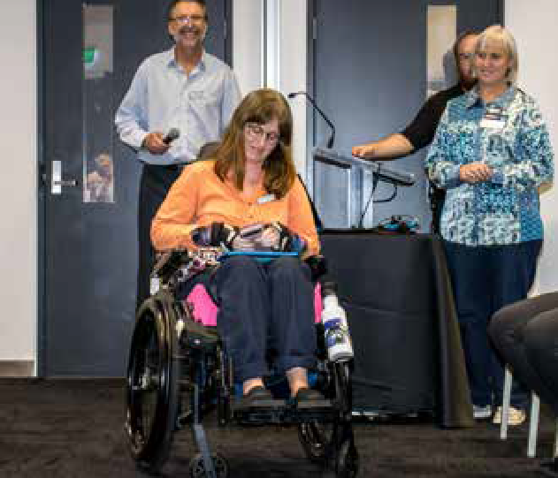
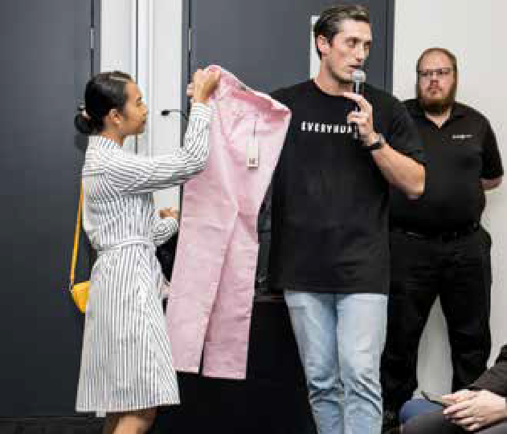
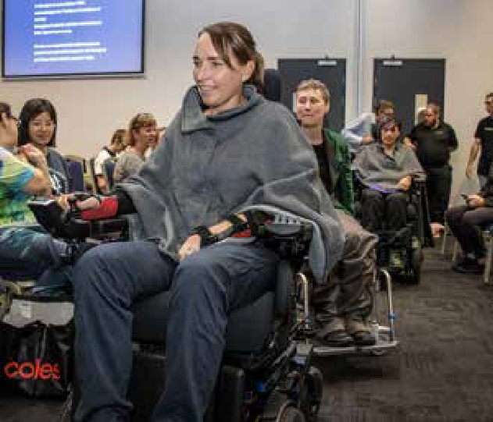

THURSDAY 1 JUNE 2023
1.00pm 45 mins

ROOM 1
ROOM 2

Deep dive into alternating air mattresses
Alexandra (Ally) Lavalle-Smith and Ankita Peter,
National Training Manager and Training and Development Coordinator NSW - Aidacare

Pressure injuries present a large personal and economic cost across healthcare settings. Alternating
air mattresses are one part of the solution.
Occupational therapists are increasingly seen as
experts in pressure care and often called upon to assess, prescribe and ensure correct functioning of alternating air mattresses.
For therapists without acute care experience, or therapists working predominantly in other areas of practice, knowledge of pressure care principles and the science behind alternating air mattress is often not established. Knowledge supports clinical reasoning and better outcomes. Therapists will be armed with knowledge on how to qualify pressure care solutions following this presentation.

What you can do to get a job for 1 million
Australians with disability
Kane Blackman - Chief Executive Officer, Good Sammy Enterprises

Kane leads Good Sammy, an iconic Western Australian charity
that operates social
enterprises in which over 300 people with a disability work and train.
His previous senior executive roles have been in the WA State Government, in private equity and in the resource sector.
Kane’s passion is working in commercial environments to drive improved outcomes for vulnerable people, which is informed by his experience as a father of a child with a rare disease.
Kane holds the following Board roles:
Chair, Ministerial Advisory Council on Disability; Non-Executive Director, Rare Voices Australia; Non-Executive Director, Therapy Focus; Member, Angelman Syndrome Association Australia; Member, Future Health Research and Innovation Advisory Council; President, Leederville Sporting Club; Non-Executive Director, Charitable Recycling Australia

THURSDAY 1 JUNE 2023
2.00pm 45 mins

ROOM 1
ROOM 2

Stand up for independence
Maryann M. Girardi,
Clinical Education Specialist, Altimate Medical, Inc.

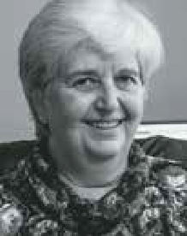
Participating in supported standing can facilitate a person’s function and quality of life. The use of standing technology can reduce spasticity, decrease contractures, and
provide sensory experiences that cannot occur in other positions which fosters improved motor skills and interactions with their environment.
Increases in strength, posture and balance are seen which enables participation
in meaningful activities and decreased dependence on others. When participating in supported standing individuals also report an improved sense of well-being, quality of life and overall health.
This course will discuss how standing can promote independence and improved quality of life for those with neurological impairments.

When manual is no longer enough – power add on considerations
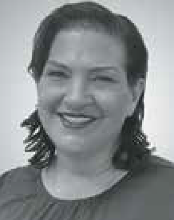
Tracee-lee Maginnity, Clinical Services Specialist -
Permobil APAC

This session will look at the development of powered assistive
technology devices that
can be added to manual wheelchairs. This area of AT encompasses a range of very different devices, how they attach, how they function, how the user accesses the drive and the impact on the manual chair are some of the points we will discuss.
We will take a look at the available evidence including a recent survey of end users that highlights the variability of device choices. From amplification of push stroke to converting a manual chair to a powered trike, we will look at some of the advantages and disadvantages of each.

