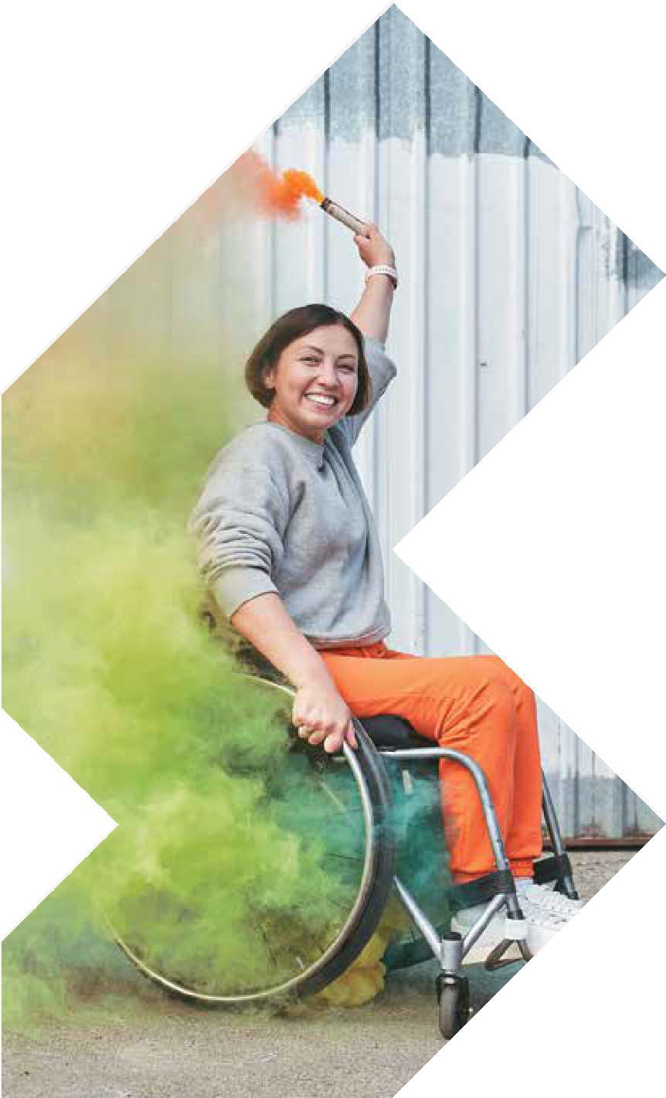
MELBOURNE
24-25 MAY 2023
MELBOURNE SHOWGROUNDS
Epsom Road, Ascot Vale

SEMINAR PROGRAM

OPENING HOURS
Wednesday 24 May 8:30am – 4:30pm
Thursday 25 May 8:30am – 3:00pm

events@atsa.org.au www.atsaindependentlivingexpo.com.au

Organised by Media Partners

WEDNESDAY 24 MAY 2023
9.15am 45 mins

Breakfast Session

8.15-9.00am
Hosted by Occupational Therapy Australia
Light breakfast provided Limited numbers

9.15am 45 mins
ROOM 1

NDIS SESSION
Kirsten Flynn and Andrea Nolan

ROOM 2

Wheelchair and seating assessment and prescription tips for working with bariatric clients
Kate Pain & Romi Russek, Clinical Educator/AT Consultant - GTK

When working with bariatric clients, there are certain considerations we need to take into account which
are unique to this population when assessing for and prescribing wheelchairs and seating. Bariatric wheelchair users are at greater risk of developing pressure injuries.
As with many clients presenting with postural asymmetry, varying body shape attributes mean that standard planar seating products may not provide appropriate postural support. There are also
particular considerations for prescribing manual and power wheelchairs for bariatric users due to the distribution of weight on the frame or base.
Kate and Romi describe how you can best evaluate postural alignment when bony prominences are less obvious, to get the best quality information from the MAT Evaluation. They will also explore the unique postural support needs for bariatric clients, such as understanding the gluteal shelf and how this can be accommodated for through utilising
specific equipment and accounting for this during the wheelchair scripting process. They will provide tips on how you can work with clients to prevent a pressure injury from occurring. Finally, there will be discussion around what equipment options are available while also considering how the user will be accessing their environment and community (car hoist weight limits, crash testing).

WEDNESDAY 24 MAY 2023
9.15am 45 mins

ROOM 3
ROOM 4

Pressure mapping is not only used to compare cushions
Dr Barend ter Haar, Director, BES Healthcare Ltd

Pressure mapping is a technology that has been in use for more
than 30 years, and over that time the technology has evolved so that
now it is as easy to use routinely as measuring
blood pressure. And, like the latter, the technology provides clinical information that cannot normally be accessed without the technology.
A valuable use of pressure mapping is to visualise whither the pressure has been redistributed as a consequence of seat and positioning adjustments. Pressure mapping allows you to see the optimum set up of the different parts of the chair – foot supports, arm supports, back support, etc – for optimal pressure redistribution. Also, using the ‘gradient’ view, the user can see the areas at greatest risk from shear strain.
This course covers what you can and what you cannot learn from using pressure mapping in clinical practice, and where,
in combination with clinical experience improved clinical outcomes are achieved.

Innovations in seating: the balance of technology and simplicity
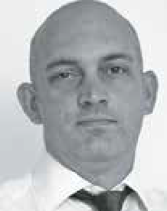
Luke Meighan, Product Manager, Mobility and Seating: Invacare Asia-Pacific

We regularly hear of new advances in technology that promise great things
in the design of equipment that we use every day. But the reality of such innovations can raise many practical considerations that need to be accounted for, such as cost, reliability, or ease of use. Such is true in the case of seating and positioning equipment.
These factors can at times impact the implementation of such technology even to the point of it being unviable altogether.
Luke will discuss a number of these considerations and demonstrate examples that show it is possible to implement innovations in a simplistic methodology that allow for positive outcomes in the seating arena.

WEDNESDAY 24 MAY 2023
9.45am 90 mins

Age Lab Workshop

ROOM 5
HALL 1
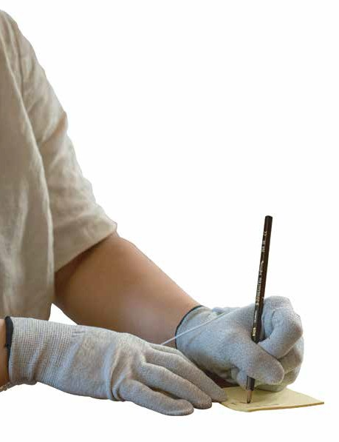
LIMITED NUMBERS

BOTH DAYS
ROOM 5
HALL 1
9.45am
90 mins

Age Lab Workshop
Adeline Chua, PhD, Senior Manager of Customer Insights at GWA

Peter Sweatman, PhD, Senior Manager Product
Visualisation at GWA

Uncover the significance of our increasingly ageing population and what it means for businesses.
Understand why so many older people want to age independently in their own homes and find out how better design can help them achieve this.
Wear the ‘AGE SUIT’ to
feel 40 years older as you try to perform everyday activities and simulated bathroom tasks. Experience the impact of health complications such as arthritis, stroke, Parkinson’s and visual impairments to understand how good and bad design affects quality of life. You will walk away with an increased sense of empathy for older people and a better understanding for how the effects of ageing can affect all aspects of daily life.
These insights will help us deliver better customer experiences for people of all ages and abilities.

WEDNESDAY 24 MAY 2023

Spotlight on Autism

ROOM 5

HALL 1

1.00pm
45 mins

From Autism Diagnosis to OAM
With Daniel Giles OAM and Daryl Giles from Speaking Insights

2.00pm
30 mins

Making Invisible Disabilities Visible
With Cristina de Moraes Leme from We Coach

3.15pm
45 mins

PANEL – Autism Support Apps
Facilitated by
Anita Aherne, Living on the Spectrum

Guests:
Michelle Ridsdale, Kaboose app
Jewel, Unique StarShine app
Dwayne Fernandes, Minds at Play

WEDNESDAY 24 MAY 2023
10.30am 30 mins

ROOM 1
ROOM 2

Parenting from a wheelchair
Curtis Palmer Assistive Technology Consultant - GTK
and Tilly Brook, Clinical Education Specialist - Permobil
Asia-Pacific

Assistive Technology has developed drastically, enabling end users
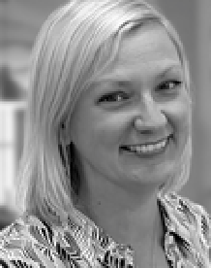
to maximise their independence and achieve a multitude of goals. But what AT solutions are available to those who are new parents and rely on wheeled mobility?
Wheelchair users are often left to do their own research and innovate
unique strategies, due to lack of information and commercially available AT solutions.
As therapists are we considering all the environments and activities a wheelchair will be used in? What accessories can we recommend to promote parenting from wheeled mobility?
This co-presentation will review firsthand accounts into parenting from a wheelchair and highlight functional considerations when trialing/scripting AT devices.

Deep dive into alternating air mattresses
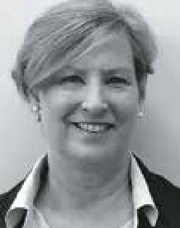
Leonie Brockman (Vic, SA/Tas) and Tish Huijbregts (Qld), Training and
Development Coordinators – Aidacare

Leonie & Tish provide product training support for staff and facilitating clinical education opportunities for local therapists. They bring skills from their background in occupational therapy with many years of experience in Community Health, Acute, Aged, and
Palliative Care.
Pressure injuries present a large personal and economic cost across healthcare settings.
Alternating air mattresses are one part of the solution. Occupational therapists are increasingly seen as experts in pressure care and often called upon to assess, prescribe and ensure correct functioning of alternating air mattresses.
For therapists without acute care experience, or therapists working predominantly in other areas of practice, knowledge of pressure care principles and the science behind alternating air mattress is often not established.
Knowledge supports clinical reasoning and better outcomes. Therapists will be armed with knowledge on how to qualify pressure care solutions following this presentation.

WEDNESDAY 24 MAY 2023
10.30am 30 mins

ROOM 3
ROOM 4

Alternative Access to Computers and Devices
Caitlin Mah, Occupational Therapist – AT Consultant

If the standard keyboard and mouse, or touch screens are difficult to use, alternative access to computers, tablets and devices can ensure ongoing operation and control.
selection of the current range of mouse alternatives including head-tracking devices and eye-gaze will be demonstrated and evaluated in relation to user application.
Parameters to be considered are overall efficiency of access, range of movement, accessibility settings, device platform and client suitability.

Functional Electrical Stimulation in practice
Rebecca Grenfell, Senior Physiotherapist, NeuroRehab Allied Health Network
and Zoe Crasborn, Senior Occupational Therapist (MCRNOT)

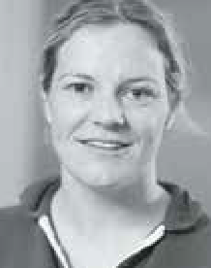
Functional Electrical Stimulation (FES )has substantial evidence to show that it can improve outcomes following neurological injuries or to manage
neurological conditions. The Physiotherapy and Occupational Therapy team at NeuroRehab
Allied Health Network commonly use it in practice.
In this presentation they will outline:
- The indications for using FES in a neuro population.
- Outline best practice set up for FES.
- Introduce FES techniques to achieve best outcomes.

WEDNESDAY 24 MAY 2023
11.30am 30 mins

ROOM 1
ROOM 2

Freedom Through Mobility
Amin Akbarian,
CEO Mobility Engineering

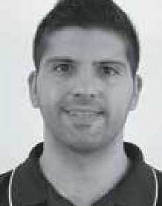
Mobility, whether it be through our own limbs, carers, vehicles, public transport, or Assistive Technology, has provided humans with the freedom to
live their life in the way they want. To be able to
access the community and be a part of the wider society has many flow-on benefits other than just providing us with daily convenience.
This session will go through the freedoms that mobility in general has provided humans as well as identifying the benefits this brings to society. The physical and psychological benefits to the individual themselves are the focus of this presentation, however we will also cover the societal benefits in having people from all walks of life participating inside of it and working together as a collective to build a more inclusive community.

Yoga – a journey of reconnection with self and community, an embodying practice for all abilities
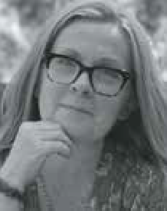
Lisa Bidgood, Occupational Therapist

A philosophical and spiritual practice, yoga cultivates health and wellbeing. Whilst
mainstream media generally depicts yoga as having a limited representation of ability, age, and body size diversity, there is growing interest within the disability and chronic health demographics.
The focus of adapted yoga is for the individual to move and connect with their sense of self whilst strengthening bonds as part of a community. In this workshop, we explore the essence of yoga with variations of asana (yoga positions), breathwork
and meditation. Yoga poses are readily adapted to meet the physical abilities of all individuals.

WEDNESDAY 24 MAY 2023
11.30am 30 mins

ROOM 3
ROOM 4

TD pilot: eye control for the iPad
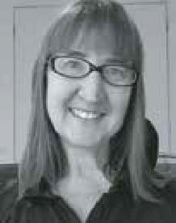
Charlene Cullen, Assistive Technology Specialist - Link Assistive

This presentation will introduce the new made for iPad (MFI) TD Pilot, which is an eye-controlled
communication device for iPad. It has been
designed to empower people with physical impairments such as MND, spinal cord injury or cerebral palsy to communicate and use their favourite apps using their eyes and other access methods.
We will demonstrate the TD Pilot which has been made for Apple’s iPadOS accessibility features and enables tasks such as tapping or scrolling using your eyes, fingers or a switch. Eye gaze users can enjoy all the content available on an iPad, including social media, games, entertainment, educational apps and more.

How adaptive clothing can benefit people with short and long term situations
Penny Weber,
The Shapes United, CEO

The way we dress has significant connection to the ways we relate to the world and the way we are perceived. It has
been proven that when people feel more engaged with how they look, they are more likely to connect with rehab programs, their peers and society.
For the longest time, people have been recommended to wear loose clothing without connection to how that makes the person feel and whether it represents them. Additionally, with falls being 40% of hospital admissions, these clothing options can create additional issues. Join this session
to learn more about the brands providing fashionable clothing options solving this issue for many people around the globe.

WEDNESDAY 24 MAY 2023
11.30am 30 mins

ROOM 5

Help Post Polio Syndrome Patients Now!
Gary Newton and Devalina Bhattacharjee, Polio Australia

Like Long COVID, Post- Polio Syndrome (PPS) is the complex of long-term after-effects of having polio.
While Polio has been eradicated in most of the world, the many survivors of polio worldwide are prone to these after-effects.
Australia, one of the leaders is treating polio in the 1950’s, is one of the leaders today in
diagnosing and treating PPS.
Attend this session to meet the experts and bring all your questions.

WEDNESDAY 24 MAY 2023
1.00pm 45 mins

ROOM 1
ROOM 2

Paediatric Panel

MODERATOR:
Robert Norman – RTD National Educator

PANELISTS:
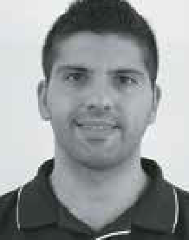
Amin Akbarian – CEO Mobility Engineering
Kate Pain – GTK Clinical Educator

Jamie Cockle – Medifab Clinical Educator
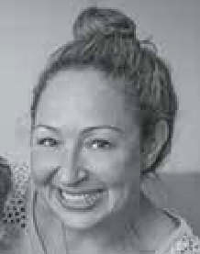
Ali Gebhardt
- Clinical Director NAPA

Changes with Age – Giving You the Justification for Custom Manual Wheelchairs for the Geriatric Client
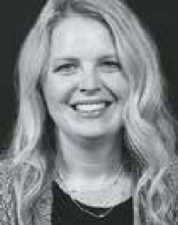
Christie Hamstra, Clinical Education Specialist, Motion Composites

The geriatric client can be easily overlooked as one who could benefit
from a custom fitting, ultralightweight, adjustable manual wheelchair. They are too often provided the “basic” wheelchair without much thought on the part of the
clinician because it requires little to no work to justify. This presentation will review how the normal aging process causes losses
in strength and muscle mass, decreased range of motion, and postural changes. Discussions will revolve around how these normal aging decreases can be intensified by disease processes that necessitate wheelchair utilization.
This session with review normal physiological changes that come with aging, and how proper wheelchair seating, base selection, fitting, and set up, can be justified for the geriatric client. A “one size fits all” approach should not be used for a geriatric client who utilizes a wheelchair for greater than six months. Participants who attend this presentation will understand how providing the geriatric client an optimally configured ultralightweight manual wheelchair versus a basic nonadjustable manual wheelchair leads to a better quantity and quality of life.

WEDNESDAY 24 MAY 2023
1.00pm 45 mins

ROOM 3
ROOM 4

Manual wheelchairs: how we apply the evidence to practice
Rachel Fabiniak, Permobil Director of Clinical Services - Asia-Pacific

There is a lot of research around manual
wheelchairs, from weight to configuration to materials of frames and accessories. What is the latest evidence?
This session will cover a review of the latest manual wheelchair literature. Then, comes the harder part – How do we apply this information to our practice? This session will conclude with how this literature can be integrated into our evidenced-based practice with case examples to discuss the application.

Innovation – a look at how the latest innovations benefit power wheelchair users
Nabil Kodsi, National Clinical Educator,
Pride Mobility

Sharing the last innovations in the power wheelchairs, the link between new
technologies being more and more part of the clinician approach to fulfilling people’s needs, and biomechanical engineering and what perspective it offers in the near future.
How can clinicians use cutting-edge technology to define, solve, and implement care treatments, rehabilitation programs, and clarify their strategies?
How can innovating assistive technology solutions empower clients’ perspectives, involve them more in their expectations, and increase self-determination?

WEDNESDAY 24 MAY 2023
2.00pm 30 mins

ROOM 1
ROOM 2

The only way is up:
The possibilities of Ceiling Lifter design and function
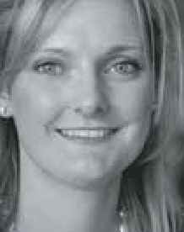
Elissa Coates - National Clinical Education Manager, Novis Health

With evidence and experience, the benefits of lifting people using ceiling based lifters is
overwhelmingly positive. Understanding Ceiling Lifters will allow you to accurately plan for the most effective solutions when solving the complexities of patient handling.
Using evidence based practice this session will ensure you have the most up to date and comprehensive information needed for Assistive Technology prescription.
In this session we will cover:
- Benefits and practicalities of patient handling with ceiling lifters
- Components of a ceiling track system
- Design types and benefits of varied set ups
- Costs and Return on Investment
- Functional and Rehabilitation possibilities

Power Assist devices – providing more than physical relief for manual wheelchair users
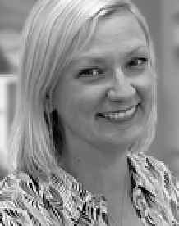
Tilly Brook, Clinical Education Specialist
- Permobil Asia- Pacific

Power assist devices were originally designed to assist manual
wheelchair users decrease the repetitive strain to the upper limb. The evolution (and number) of these products has grown significantly. As a therapist, it can be difficult to determine which type of device may be best.
In this session we will discuss the most up to date evidence with lived experiences of those using Power Assist Devices (PADs). By the end of this session, clinicians should be able to understand the benefits and differences of PADs. This will assist in determining which solution will best meet the needs and goals of an individual.

WEDNESDAY 24 MAY 2023
2.00pm 30 mins

ROOM 3
ROOM 4

Frame Running - a new Para Athletics event for people with high support needs in balance and mobility
Sarah Reedman, Research Fellow, The University of Queensland

Frame Running is a new innovative Para Athletics event for people living
with high support needs in balance and mobility. It uses a 3-wheeled running frame with a saddle, chest support and handlebars for steering. Frame Running (formerly known as RaceRunning) was developed by Danish Para Athletes Connie Hansen (also an Occupational Therapist) and Mansoor Siddiqi in the early 1990s, with the discipline exploding in popularity across Europe in
the following years and eventually Australia from 2018. This session will introduce the discipline of Frame Running for attendees, and touch on:
- Basic properties of the running frame (with live demonstration by supplier Dejay Medical)
- Who can participate
- How to get involved
- Research on the benefits of Frame Running, including research conducted by The University of Queensland led by Dr. Sarah Reedman
You will leave with a broad understanding of this exciting accessible physical activity and ideas about how to participate and/or support others to participate.

How are the surfaces and shape important to prevent pressure sores?
Martino Avellis, PT - Ormesa s.r.l.

The contact surfaces shape and the kind of material which they are made of, are very crucial issues to figure out the consequences on the skin integrity of the users
sitting on a wheelchair. Furthemore, we have to consider how a contact surfaces can grant breathability and moisture absence, in order to avoid the increasing skin temperature and local humidity.
In this study, we demonstrated that a particular backrest shape and a particular material used for the backrest as well as for the seat, can work decreasing significantly the interface pressure on the user’s skin, even without using a specific anti decubitus cushion.

WEDNESDAY 24 MAY 2023
3.15pm 45 mins

ROOM 1
ROOM 2

Bums, Bowels, and Bladder: Plane Travel and Things to Consider for Wheelchair Users
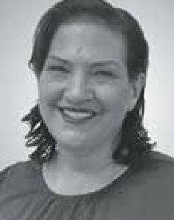
Tracee-lee Maginnity, Clinical Services Specialist -
Permobil APAC

What main things do wheelchair users need to consider prior to plane travel and what supports
are out there to assist? How do we make sure pressure care needs are met on long- haul flights and how can wheelchair users safely complete their bladder and bowel care 30,000 feet high?
This presentation will review current EBP with reference to best practice guidelines for pressure care and bladder and bowel management and dive into practical solutions to ensure this can be completed on a plane.

Addressing the effects of tone, spasticity, and other neurologic symptoms on the seated posture
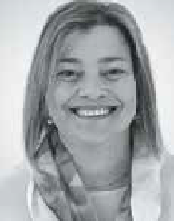
Lois Brown, ILS National Clinical Education Manager

Neurological diagnoses provide a range of physical and cognitive
impairments. While each diagnosis varies, there are common sequalae which affect seating and positioning goals for an individual with a mobility impairment.
Abnormal neurologic motor and muscle impairment require varying approaches in a seated position.
This session will cover the assessment and strategies to manage the effects of tone and spasticity, muscle imbalance, postural control issues along with specific considerations for several neurological diagnoses such as ABI, CVA, MND and CP.

WEDNESDAY 24 MAY 2023
3.15pm 45 mins

ROOM 3
ROOM 4

MAT 101 – Next Steps - So You’ve Taken a MAT 101 Course –
How do you implement those skills into your
wheelchair prescription process?
Amy Bjornson, Clinical Director, Sunrise Medical

In this workshop, we will implement your newly acquired MAT evaluation skills. We’ll translate assessment findings into problem lists and provide strategies to create seating solutions to foster appropriate postures
and maximise functional outcomes. Using outcome measures and client centered approaches, you’ll become more confident in selecting appropriate equipment for trial.
This session is case study based to maximize learning and give you confidence during equipment trials.

Why does equipment for children need to be so different from that for adults?
Dr Barend ter Haar, Director, BES Healthcare Ltd

Paediatric equipment is not just adult equipment made smaller. If a child has an impairment, be
it mental, physical, or
behavioural, they still have the same spatial, physical, mental, and social development needs and processes to be catered for, as for any other child.
This course looks at aspects of the 24- hour needs of a youngster and how their environment and equipment can help them develop positively, as compared with growing up learning to be ‘disabled’. The course covers the needs of the child, alongside family, social, and educational
needs, and what we need to do to ‘facilitate’ normal development to the highest degree possible.

THURSDAY 25 MAY 2023
8.30am 90 mins 9.15am 45 mins

ROOM 2
ROOM 1

BREAKFAST SESSION 8:30 - 10:00am

Mat evaluation 101 for wheelchair skills training – tips, tricks and
advice from what I have learned along the way....
Amy Bjornson, Clinical Director - Sunrise Medical

This workshop is for therapists involved in seating and wheelchair assessment. In
this session, we will demonstrate the client assessments - both supine and sitting. We’ll provide practical tips and tricks to make you much more comfortable doing a MAT assessment.
You will learn how to perform the skills on a variety of client types. We will consider which steps can be skipped for less complex clients, what is critical for complex cases and how to alter the process to work for your bariatric clients.
Please note: a light working breakfast will be served.

Environment, environment, environment – specialised intervention in children and adolescents with unilateral Cerebral Palsy
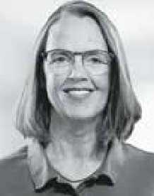
(uCP)
Andrea Espei, head of training at Schuchmann Reha, Germany

Therapy for children
with uCP, over the last 15 years, there has been a lot of movement. Forced Use, Constraint Induced Movement Therapy (CIMT), Bimanual Therapy, Occupation Based Therapy – we have learned a lot.
But, in times of inclusion and participation is it enough to focus on therapy, motor learning and concepts? What about the environmental factors?
The impact of sitting positions in every day settings in school, at home, for leisure is imense on either motor developement and autonomy of a child or adolescent.
This session is about creating every day situations and shaping the environment to support bimanual activies in every day life. During this session some case studies from around the world willl be presented.
After this presentation you will:
- have an overview about therapy in uCP
- be aware of the impact environmental factors have on motor development
- have learnt about positioning in daily activities to support bimanual activities

THURSDAY 25 MAY 2023
9.15am 45 mins

ROOM 3
ROOM 4

Stand up for independence
Maryann M. Girardi, Clinical Education Specialist, Altimate Medical, Inc.

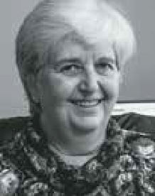
Participating in supported standing can facilitate a person’s function and quality of life. The use of standing technology can reduce spasticity, decrease contractures, and
provide sensory experiences that cannot occur in other positions which fosters improved motor skills and interactions with their environment.
Increases in strength, posture and balance are seen which enables participation
in meaningful activities and decreased dependence on others. When participating in supported standing individuals also report an improved sense of well-being, quality of life and overall health.
This course will discuss how standing can promote independence and improved quality of life for those with neurological impairments.

Postural Care: the rise of therapeutic positioning in the lying posture around the world
Anna Goldsmith, Director, Simple Stuff Works Associates Ltd and
Joana Santiago, Clinical Educator, Medifab

This seminar will look at the development of Postural Care provision
from its infancy in the UK in the 1970s through to the global recognition it is now receiving.
The seminar will discuss how research into the biomechanics of body
shape distortion has developed over the last 45 years and how therapists are using this to develop best practice in this field to protect body shape of those people they support.
We will debunk some of the myths and misconceptions that are surfacing around this topic and share best practice examples from the UK.

THURSDAY 25 MAY 2023
9.45am 90 mins

Age Lab Workshop

ROOM 5
HALL 1
LIMITED NUMBERS

BOTH DAYS
ROOM 5
HALL 1
9.45am
90 mins

Age Lab Workshop
Adeline Chua, PhD, Senior Manager of Customer Insights at GWA

Peter Sweatman, PhD, Senior Manager Product
Visualisation at GWA

Uncover the significance of our increasingly ageing population and what it means for businesses.
Understand why so many older people want to age independently in their own homes and find out how better design can help them achieve this.
Wear the ‘AGE SUIT’ to
feel 40 years older as you try to perform everyday activities and simulated bathroom tasks. Experience the impact of health complications such as arthritis, stroke, Parkinson’s and visual impairments to understand how good and bad design affects quality of life. You will walk away with an increased sense of empathy for older people and a better understanding for how the effects of ageing can affect all aspects of daily life.
These insights will help us deliver better customer experiences for people of all ages and abilities.

THURSDAY 25 MAY 2023

Spotlight on Autism

ROOM 5

HALL 1

1.00pm
45 mins

PANEL – Sensory Self-Harm Prevention
Facilitated by Anita Aherne, Living on the Spectrum

Guests:
Annelil Desille, Own your Mental Joanne Seymon, Kaiko Fidgets Emma Clegg, Jam the Label

2.00pm
30 mins

Maximising Autism Support with Allied Health Assistants
Nikita Fernandes, FORA

THURSDAY 25 MAY 2023
10.15am 30 mins

ROOM 1
ROOM 2

TGA
Rebecca Bateson,
A/g Director – Devices Emerging Technology and Diagnostics Medical Devices
Surveillance Branch

Toileting and special needs: where to start?
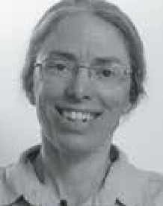
Lori Potts, Physical Therapist, Rifton Product and Training Specialist

For many parents and teachers of children with special needs, toilet training can seem like an unattainable goal. Each child has unique health issues, physical disabilities,
emotional/behavioral challenges, cognitive and learning disabilities as well as communication barriers.
Nevertheless, an individualized, consistent toileting routine can have a significant and positive impact on quality of life, with improved continence and toilet training success outcomes.
How to begin? This session equips the clinician with evidence-based information and resources with which to move forward and support families and schools to address this central issue.

THURSDAY 25 MAY 2023
10.15am 30 mins

ROOM 3
ROOM 4

Assistive technology (AT) in Australia: current
opportunities and challenges for the AT sector.
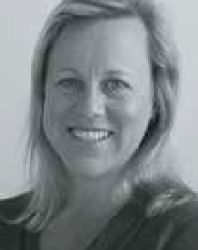
Associate Professor Libby Callaway, President, Australian Rehabilitation and Assistive Technology Association (ARATA)

Australia continues to undergo major reforms across health, ageing and disability. These reforms are significant for both people who use Assistive Technology (AT), as well as those who advise on or supply AT. This presentation by Board Members of the Australian Rehabilitation and Assistive Technology Association (ARATA) – a national peak body for AT stakeholders
– will outline current opportunities and challenges in the AT sector, and link these to global AT policy.
Information resources and strategies to inform both consumer and service provider experiences of AT products, provision, personnel and policy will be detailed.
Recommendations for further action in the AT sector will be discussed.

The benefits of electric assisted trikes for people living with disability,
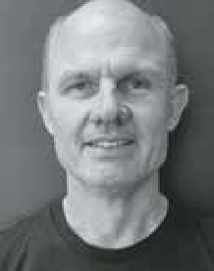
Richard Herklots, Owner-operator, everyBody eBikes

The Covid pandemic and a move to a more sustainable lifestyle have seen a resurgence in cycling. Many people with a disability may want to enjoy the
outdoors through cycling, but do not have the physical strength or balance to ride a traditional bike and have given up on the idea. Cycling offers many benefits beyond exercise including social participation, independence and freedom. For children, cycling is seen by many as a right of passage and electric assistance allows them to move around their environment “at speed” and process events at a faster rate than would be possible on a mechanical bike.
Electric assistance allows riders to participate: to go further, to ride in the park on grass (challenging even on a traditional bike), to ride up those dreaded hills and enjoy being outside, joining in the fun.
This session will discuss different types of electrical assistance and some of the innovations developed to assist people to ride bikes and trikes.

THURSDAY 25 MAY 2023
11.00am 45 mins

ROOM 1
ROOM 2

Improving AT outcomes by strengthening the collaboration of the AT supplier and therapist
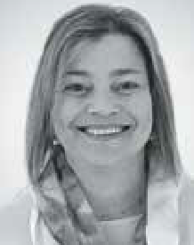
Kim Vien, Senior Occupational Therapist (Royal Melbourne Hospital, Wheelchair and Seating Clinic as part of the Young Adults Transition Service)
& Lois Brown, National Clinical Education Manager for ILS

Working relationships are formed when developing Assistive Technology
solutions for people with disabilities. This session will delve into the relationship formed by AT suppliers and prescribing therapists. It will explore the roles of
each party, the strategies to improve communication between each other and how this working relationship can get the best AT solutions for our clients.
We will be presenting some case studies, examples of templated documents therapists can use and discuss how to approach scripting when there is inequity with experience. This session will benefit new therapists and AT suppliers entering the Assistive Technology Space.

Need not niche - power wheelchair assessment to provide freedom & function
Scott Staunton, Rehabilitation Engineer / Client
Sales Manager:
Magic Mobility

The challenge and goal for therapists when evaluating for appropriate
powered mobility is knowing the available technology to enable maximum
independence and function for accessing all aspects of daily life.
Many of the clinical benefits associated with dynamic seating have research in place to help support clinical justification. However, the same cannot be said to help support the use of equipment when looking to engage in life aspects such as work, family, travel, and recreation utilising these same functions.
This session gives participants a good understanding of assessment processes for powered mobility helping facilitate client engagement and maximize independence/ function.

THURSDAY 25 MAY 2023
11.00am 45 mins

ROOM 3
ROOM 4

When manual is no longer enough – power add on considerations
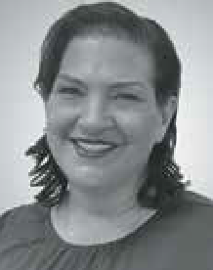
Tracee-lee Maginnity, Clinical Services Specialist - Permobil APAC

This session will look at the development of powered assistive
technology devices that
can be added to manual wheelchairs. This area of AT encompasses a range of very different devices, how they attach, how they function, how the user accesses the drive and the impact on the manual chair are some of the points we will discuss.
We will take a look at the available evidence including a recent survey of end users
that highlights the variability of device choices. From amplification of push stroke to converting a manual chair to a powered trike, we will look at some of the advantages and disadvantages of each.

Managing Behaviours of Concern Through Wheelchair Interventions That Allow
for Sensory Expression and Enhance Participation
Lauren Hunter, Director of Clinical Services, Linds Rehabilitation Equipment

We all have ways in which we communicate and express ourselves. At times, individuals with disability are labelled as having “behaviours of concern” because their communication, sensory and functional needs are not being met. Often these individuals are also wheelchair users who become reliant on their wheelchairs not only for mobility, but
for enhanced participation and socialisation through meaningful ADLs. What happens when certain features prescribed with good intention, are used in ways that promote restrictive practices? Are there features
of wheelchairs, that when appropriately prescribed, reduce agitation to enhance sensory and motor experiences for those users who have been labelled “destructive” and “difficult”.
Together, we can unravel the assessment process essential to understanding the individual in the wheelchair. We will discover intervention practices to consider, that will lead to a deeper understanding of how the features you prescribe in a wheelchair can help the goals you set to improve the quality of life for this population demographic.

THURSDAY 25 MAY 2023
1.00pm 30 mins

ROOM 1
ROOM 2

Adaptive Clothing Fashion Show
Why SOS wristwatches differ from smartwatches by Apple, Samsung and others
Lance Starke, Co-Owner of Guardian Safety Pendants

Now that telecommunication technologies are available in a wristwatch:
- What are the significant differences between a smartwatch from Apple or Samsung and an SOS wristwatch?
- Are they all just miniature mobile phones with different APPs, bells and whistles?
- What the difference between a children’s phone watch and one an adult would use?
- How useful is the tele-health functionality of a wristwatch?
- What challenges might seniors or those with a disability face in using a dedicated SOS wristwatch?
These are some of the points to be addressed. Come prepared to see and hear a Show-And-Tell rather than be dazzled with techno-babble.

THURSDAY 25 MAY 2023
1.00pm 30 mins

ROOM 3
ROOM 4

Up-to-date physical activity guidelines:
rising to the challenge
Lori Potts, Physical Therapist,
Rifton Product and Training Specialist

Children and adults with significant physical disabilities are often
relegated to the sidelines
of life, with passive positioning that results in worsening deformities and ill-health.
The field of therapy widely recognizes that opportunities for physical activity will bolster health and well-being.
Current physical activity guidelines provide specific physical activity recommendations for children and adults with disabilities.
This session will provide current knowledge to support effective parent and therapist decision-making and discuss solutions to enable opportunities for physical activity in home, school, and community.

The importance of choice and control
ATSA

In this seminar you will begin to understand the importance for all involved, Client/
End User and AT provider to have a choice enabling them to follow through the assessment process, including why
sometimes less is in-fact more when it comes to scripting.

THURSDAY 25 MAY 2023
2.00pm 30 mins

ROOM 1
ROOM 2

Diversifying standing opportunities for children: What are the options and how do we clinically reason and provide
justification for funding them?
Jamie Cockle, Clinical Educator Medifab

Prolonged sitting is regarded by many to be an emerging public health concern.
Whilst the need for us to regularly move and change position throughout our day is now widely recognised, for those with a
physical disability, access to positions such as standing or weight bearing remains a big challenge.
The benefits of supporting standing for children with physical impairment must be understood by all stakeholders in a way that is meaningful. To achieve optimum outcomes, selection of appropriate equipment must be based on individual needs. Information gleaned from assessment is vital in informing selection of appropriate standing frames and the accessories used to tailor their support and achieve success. Understanding this is vital to optimising function of the user whilst also understanding contraindications for device use.
This presentation provides an introduction to the different styles of standing/ weightbearing that can be supported through equipment provision.

Power functions that create unique client centered solutions
Lauren Hunter, Director of Clinical Services, Linds Rehabilitation Equipment

Often the difference between disability and ability is application
of assistive technology that matches the unique functional abilities of our clients. There have been many advances in technology for how individuals who use powered mobility can add on specialized seating functions and controls to enhance their participation in the world that surrounds them.
Join us to explore the clinical applications of powered lateral tilt, latitude (seat to floor), anterior tilt and standing functions; along with alternate drive control systems, that through clinical application, have vastly improved the quality of life for the unique individuals we will showcase through our clinical studies.
We will explore the research available to assist in our decision making and ensure we use outcome measures that showcase client centered processes aren’t lost in a tick box society.

THURSDAY 25 MAY 2023
2.00pm 30 mins

ROOM 3
ROOM 4

Are adjustable wheelchair cushions better?
Tom Whelan, Vice President Product Development at Ki Mobility

Adjustable wheelchair cushions are often considered the ultimate solution for clients at high risk of pressure injuries. We will discuss what defines an adjustable wheelchair
cushion, how the technology works, and what it should accomplish when properly constructed, adjusted and used.
Every interaction between an individual and a different cushion is a unique result of those two specific variables at that point in time. It is important to trial whether a specific cushion can be properly adjusted for any individual’s seating needs, and to know if the adjustable characteristics of the cushion will be able to accommodate changes in clients’ needs over time.

Ages and stages - positioning through the day in the real world
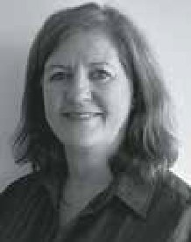
Jacinta Maurin, Clinical Hub, Sunrise Medical

What AT do you need when?
Tracing the path from being newly diagnosed onward, this session will
help you identify what seating and mobility solutions can help maximise independence and function. With a paediatric focus we’ll consider how best to integrate AT to assist with engaging children through the day.
Come find out what questions to ask and how best to determine supports needed moving through childcare, kindy and upward.
Identify different positioning options that work over a range of environments and how to successfully prescribe them.
Jacinta brings to the Sunrise Clinical Hub team 25+ years of experience in the
assistive technology industry. Trained as a Physiotherapist, Jacinta is passionate about supporting kids and families in reaching their goals and finding solutions to supporting kids.

